## ParKing | A Smart Parking System

**BY**

## MOTAWASH SEMEEN CHOWDHURY

## ID: 201-15-14166

This Report is presented in Partial Fulfillment of the Requirements for the Degree of Bachelor of Science in Computer Science and Engineering

Supervised By

# Mr. Raja Tariqul Hasan Tusher

Assistant Professor Department of CSE

Daffodil International University Co-Supervised By

**Mr. Tanvirul Islam**

Lecturer Department of CSE

Daffodil International University



# DAFFODIL INTERNATIONAL UNIVERSITY

**DHAKA, BANGLADESH**

# APPROVAL

This Project titled “**ParKing**”, submitted by Motawash Semeen Chowdhury to the Department of Computer Science and Engineering, Daffodil International University has been accepted as satisfactory for the partial fulfillment of the requirements for the degree of B.Sc. in Computer Science and Engineering and approved as to its style and contents.

# BOARD OF EXAMINERS

## Dr. Syed Akhter Hossain

**Chairman Professor and Head Chairman**

Department of Computer Science and Engineering Faculty of Science & Information Technology Daffodil International University

## Dr. Sheak Rashed Haider Noori Internal

**Professor & Head**

Department of Computer Science and Engineering Faculty of Science & Information Technology Daffodil International University

## Dr. Mohammad Shorif Uddin External

**Examiner Professor and Chairman**

Department of Computer Science and Engineering Jahangirnagar University

# DECLARATION

We hereby declare that, this project has been done by us under the supervision of **Mr. Raja Tariqul Hasan Tusher, Assistant Professor, Department of CSE** Daffodil International University. We also declare that neither this project nor any part of this project has been submitted elsewhere for award of any degree or diploma.

## Supervised By Co-Supervised By

**Mr. Raja Tariqul Hasan Tusher Mr. Tanvirul Islam**

Assistant Professor Lecturer

Department of CSE Department of CSE

Daffodil International University Daffodil International University

## Submitted by:

**Motawash Semeen Chowdhury**

**ID: 201-15-14166**

Department of CSE

Daffodil International Universi

ACKNOWLEDGEMENT

We extend our sincere gratitude to the Almighty for bestowing divine blessings that enabled us to successfully complete our final year project.

The true essence of accomplishing a goal lies in the pursuit of excellence and rigorous discipline. Without the cooperation, encouragement, and assistance provided by various individuals, our task would not have been accomplished.

Our heartfelt appreciation goes to our supervisor, Mr. Raja Tariqul Hasan Tusher (Assistant Professor), and co-supervisor, Mr. Saiful Islam, BSc in CSE Program, Daffodil International University. Their unwavering patience, scholarly guidance, continual encouragement, energetic supervision, constructive criticism, valuable advice, and meticulous review of numerous drafts at all stages were instrumental in the completion of this project. We express our special gratitude to our esteemed teachers.

We would like to convey our deepest thanks to Dr. Syed Akhter Hossain, Head of the Department of CSE, for his kind assistance in finalizing our project. We also acknowledge with great appreciation the indispensable role played by the staff of Daffodil International University (DIU), who granted us permission to access library materials and equipment, facilitating our knowledge acquisition and understanding. We express our gratitude for the guidance provided by other supervisors and lecturers who contributed to clarifying our understanding and emphasized the importance of completing the project report with meticulous care and high quality.

Our thanks are also extended to our fellow course mates at Daffodil International University who engaged in discussions during the coursework.

Lastly, we cannot overlook the constant support and patience of our parents, and we acknowledge them with utmost respect

# ABSTRACT

"ParKing: A Smart Parking System" is a revolutionary project designed to address the challenges associated with traditional parking systems by introducing a user-friendly and efficient solution. This system aims to streamline the parking experience for both users and lot owners, fostering a seamless and organized approach to parking space management.

The key features of ParKing include instant hourly booking of parking slots, allowing users to conveniently secure parking spaces based on their specific time requirements. Users also have the option to advance book parking slots, providing a hassle-free solution for planning and ensuring parking availability during peak hours.

Moreover, ParKing enables users to easily locate and identify available parking slots within a designated area, enhancing overall convenience and reducing the stress associated with finding suitable parking spaces.

For lot owners and space providers, ParKing offers a lucrative opportunity to optimize their parking assets. Owners can list their vacant parking lots on the system, transforming them into potential income sources. This not only maximizes the utilization of parking spaces but also contributes to the efficient allocation of urban resources.

With ParKing, the parking ecosystem evolves into a dynamic, user-centric, and economically viable model. The implementation of this smart parking management system promises to enhance the overall parking experience, benefiting both users and lot

Owners in urban settings.

# TABLE OF CONTENTS

**CONTENTS PAGE NO**

Approval i

Declaration ii

Acknowledgement iii

Abstract iv

CHAPTER

CHAPTER 1: INTRODUCTION 01-06

* 1. Introduction 01
  2. Motivation 02
  3. Aims and Objectives 03
     1. Aims of the project 03
     2. Objective of the project 03
  4. Feasibility Study 04
  5. Expected Outcome 06
  6. Report Layout 06

CHAPTER 2: BACKGROUND 07-13

* 1. Introduction 07
  2. Related Works 08
  3. Comparative Studies 11
  4. Scope of the Problem 11
  5. Challenges 11
     1. What are we thinking? 12
     2. Young Researchers 12
     3. Time 13
  6. Summary 13

CHAPTER 3: REQUIREMENT SPECIFICATION 14-20

* 1. Android Studio 14
     1. System Requirements 17
  2. XAMPP 19
     1. Usage 19
  3. Sublime Text 20
     1. Features 20

CHAPTER 4: PROPOSED MODEL AND DESIGN 21-29

* 1. Block Diagram 21
  2. Description of Application 22
  3. Use Case Modeling and Description 23
  4. System Architecture 27
  5. E-R Diagram and Description 28

CHAPTER 5: IMPLEMENTATION AND TESTING 30-43

* 1. Implementation of Front-End Design 30
  2. Implementation of Back-End Design 37
     1. Data Table Name 37
     2. Data Type Architecture 38
     3. MySQL Database View 40
     4. Database Table Structure 40
  3. Testing Implementation 41
     1. Testing Methodology 42
     2. Functional Testing 42
     3. Unit Test 42
     4. Compatibility Test and Result 43

|  |  |
| --- | --- |
| **CHAPTER 6: CONCLUSION AND FUTURE SCOPE** | **44-44** |
| 6.1 Conclusion | 44 |
| 6.2 Goal | 44 |
| 6.3 Limitation | 44 |
| 6.4 Scope for Further Developments | 44 |
| **REFERENCES** | **45** |
| **LIST OF TABLES** |  |
| **TABLES** | **PAGE NO** |
| Table 1.1: Specific Options for Teachers and Students | 03 |
| Table 3.1: Version 3.x | 17 |
| Table 3.2: Version 2.x | 17 |
| Table 3.3: Version 1.x | 18 |
| Table 4.1 Use Case Analysis | 24 |
| Table 5.1: Compatibility Test Result | 43 |
| **LIST OF FIGURES** |  |
| **FIGURES** | **PAGE NO** |
| Figure 3.1: Interface of Android Studio | 15 |
| Figure 3.2: Android Studio SDK Manager | 16 |
| Figure 4.1: Block Diagram | 21 |
| Figure 4.2: Use Case Diagram | 23 |

|  |  |
| --- | --- |
| **FIGURES** | **PAGE NO** |
| Figure 4.3: System Architecture | 27 |
| Figure 4.4: E-R Diagram | 29 |
| Figure 5.1: Smart Classroom Home Activity | 30 |
| Figure 5.2: Sign Up and Sign Up Form Fields Validation | 31 |
| Figure 5.3: Log In and Log In Fields Validation | 32 |
| Figure 5.4: Home Activity and Noticeboard | 33 |
| Figure 5.5: Specific Options for Teachers and Students | 34 |
| Figure 5.6: Attendance | 35 |
| Figure 5.7: Self Evaluation Test and Remarks | 35 |
| Figure 5.8: Result Publish | 36 |
| Figure 5.9: Routine and Students Problems View | 36 |
| Figure 5.10: Data Table Name | 37 |
| Figure 5.11: Data Type Architecture | 39 |
| Figure 5.12: MySQL Database View | 40 |
| Figure 5.13: Database Table (teacher_info) | 40 |

ix

# CHAPTER 1 INTRODUCTION

## Introduction

In contemporary urban landscapes, the escalating challenges of parking management necessitate innovative solutions that cater to the evolving needs of both users and parking space owners. "ParKing: A Smart Parking Management System" emerges as a groundbreaking project designed to revolutionize the traditional parking experience. This system is conceived with the vision of introducing a user-centric, efficient, and economically viable approach to parking space allocation and utilization.

Recognizing the limitations of conventional parking systems, ParKing addresses the common issues faced by users, such as the struggle to find available parking spaces, especially during peak hours. The project introduces a dynamic solution that allows users to instantly book parking slots on an hourly basis, offering flexibility and convenience in aligning parking needs with specific time requirements.

ParKing goes beyond individual user benefits by incorporating features that cater to the interests of parking lot owners and space providers. By allowing them to list their empty parking lots on the system, ParKing transforms idle spaces into potential income sources. This not only optimizes the use of parking assets but also contributes to a more efficient allocation of urban resources.

This introduction sets the stage for a comprehensive exploration of the ParKing project, shedding light on its key functionalities and the transformative impact it promises to bring to the urban parking landscape. As we delve into the details of ParKing, it becomes evident that this smart parking management system represents a pivotal step towards a more organized, user-friendly, and economically sustainable approach to parking.

## Motivation

The motivation behind the inception of "ParKing: A Smart Parking Management System" is deeply rooted in addressing the persistent challenges and inefficiencies prevalent in traditional parking systems within urban environments. The burgeoning urbanization and increasing vehicular density have underscored the urgent need for a smarter, more responsive solution to streamline the parking experience for both users and parking space owners.

The inspiration for ParKing stems from the recognition of the daily struggles faced by users in finding suitable and available parking spaces. We are motivated by the desire to alleviate the stress and uncertainty associated with parking, especially during peak hours when demand often surpasses supply. The aim is to empower users with a tool that not only provides instant hourly booking options but also allows for advanced planning, ensuring a seamless and stress-free parking experience.

Moreover, the motivation extends to the optimization of parking assets for lot owners and space providers. Recognizing the untapped potential of empty parking lots, ParKing seeks to transform them into valuable income sources. This dual-purpose approach not only meets the immediate needs of users but also contributes to the efficient use of urban space and resources.

The overarching motivation for ParKing lies in envisioning a future where parking is no longer a source of frustration but rather a seamlessly integrated and user-centric aspect of urban living. By introducing innovative features and functionalities, ParKing aspires to redefine the conventional norms of parking management, offering a model that is dynamic, economically viable, and capable of adapting to the evolving needs of modern urban environments. Through ParKing, we are driven to contribute to a more efficient, convenient, and sustainable urban mobility landscape.

## Aims and Objectives

The "ParKing: A Smart Parking Management System" project is driven by a set of clear and strategic aims and objectives, each designed to address specific challenges in the realm of parking system. The primary aims and objectives of this project are as follows:

* Enhance User Experience:

Enable users to instantly book hourly parking slots, providing flexibility and convenience in aligning parking needs with specific time requirements. Facilitate advanced booking options to empower users with the ability to plan ahead, ensuring parking availability during peak hours and special events.

* Efficient Space Utilization:

Provide parking lot owners and space providers with a platform to list and monetize their vacant parking spaces, optimizing the utilization of urban parking assets. Contribute to the efficient allocation of parking resources by transforming idle spaces into potential income sources for lot owners.

* Location-based Parking Search:

Empower users to easily find and identify available parking slots within a designated area, reducing the time and stress associated with searching for suitable parking spaces.

* Seamless Integration for Lot Owners:

Design an intuitive interface for parking lot owners to effortlessly upload and manage information about their available parking spaces on the ParKing platform. Provide a user-friendly dashboard for lot owners to monitor bookings, track revenue, and manage their parking inventory efficiently.

* System Scalability and Reliability:

Develop a scalable and robust system architecture to accommodate a growing user base and expanding parking infrastructure. Ensure the reliability and stability of the ParKing platform, minimizing downtime and disruptions in service.

* User and Lot Owner Education:

Conduct outreach and educational initiatives to familiarize both users and parking lot owners with the features and benefits of the ParKing system. Provide training resources and documentation to ensure that users and lot owners can maximize the potential of the smart parking system.

* Data Security and Privacy:

Implement robust security measures to safeguard user data and transaction information. Ensure compliance with privacy regulations and standards to build trust among users and lot owners in the ParKing system.

Through these aims and objectives, the ParKing project aims to not only revolutionize the parking experience for users but also create a symbiotic relationship between users and parking space owners, fostering a more efficient and economically viable urban parking ecosystem.

## Aims of the Project

The main aims of this project are as follows

* + - * Exposure to a smart parking system
      * Make easy to use information technology
      * Save your time and money
      * Is willing to try new technology
      * Is comfortable with sharing his empty space
      * User-Friendly IT Integration

## Objectives of the Project

The main objectives of this project are as follows:

**Table 1.1: Specific options for teachers and students**

|  |  |
| --- | --- |
| **User** | **Admin** |
| * Can create, delete, update profile * Can view parking locations by using user current location * Can view parking locations by entering a location name * Can list their empty area * Can edit, delete their uploaded area * Can post review * Can pay via Cash, Card, online * Can view or download Invoice * Receive mail after successful slot book and registration | * Can create, delete, update profile * Can delete, edit user profile * Can delete, update, list parking slot * Can see, delete user review * Can see or download invoice * Can view total empty or occupied parking slots * Total transaction amount |

## Feasibility Study

The feasibility study for the "ParKing: A Smart Parking System" project encompasses a comprehensive analysis to assess the viability and practicality of its implementation. The study focuses on key aspects, including technical, economic, operational, scheduling, and legal considerations, to determine the project's likelihood of success.

* **Technical Feasibility:**

Assessment of Technology: Evaluate the technical requirements and capabilities of implementing a smart parking system, ensuring compatibility with existing infrastructure.

System Scalability: Determine the system's scalability to accommodate a growing user base and evolving parking infrastructure.

Data Security Measures: Analyze the feasibility of implementing robust data security measures to protect user information and transactions.

* **Economic Feasibility:**

Cost-Benefit Analysis: Conduct a thorough cost-benefit analysis to assess the financial viability of the project, considering development, maintenance, and operational costs against potential revenue streams.

Return on Investment (ROI): Evaluate the expected ROI for both users and parking lot owners, considering the income generation potential for the latter.

* **Operational Feasibility:**

User-Friendly Interface: Examine the feasibility of creating a user-friendly interface to ensure ease of use for both individuals and parking space providers.

Training and Adoption: Assess the ease of training users and parking lot owners on the system, promoting widespread adoption.

Impact on Operations: Evaluate how the implementation of ParKing may impact the current operational processes of parking lot owners.

* **Scheduling Feasibility:**

Project Timeline: Develop a realistic project timeline, considering the development, testing, and deployment phases.

Dependencies and Constraints: Identify potential dependencies and constraints that may affect the project schedule and address them proactively.

* **Legal Feasibility:**

Regulatory Compliance: Ensure compliance with local regulations and legal requirements governing parking systems and data privacy.

Contracts and Agreements: Evaluate the feasibility of establishing clear contracts and agreements with parking lot owners regarding the use of the ParKing platform.

The feasibility study will provide a comprehensive understanding of the project's viability, allowing stakeholders to make informed decisions regarding the initiation and execution of the "ParKing" smart parking system.

## Report Layout

Report layout describes a summary of all the chapters. A brief summary of all chapters is given below:

* **Chapter 1:** Describes an introduction of the ParKing, Motivation, Aims and Objectives, Feasibility study and the Report layout.
* **Chapter 2:** Describes the background, the related works, Comparative Studies and Challenges of the parking system.
* **Chapter 3:** Describes the Laravel, System requirements, XAMPP, Visual Code.
* **Chapter 4**: Describes the Block diagram, Description of application, Use case modeling and description, System architecture, E-R diagram and description.
* **Chapter 5:** Describes the Implementation of Front-end design, Back-end design, Data table name, Data type architecture, MySQL database, Database table structure, Testing methodology, Functional testing, Unit test, Compatibility test and result.
* **Chapter 6:** Describes the conclusion where the goal, limitation and future scope have been described.

# CHAPTER 2 BACKGROUND

## Introduction

Though in other countries many projects have been done to explore the effective way of smart parking system and operational successfully, but very few of them have been conducted in the context of Bangladesh. There are several organizations which are trying to research and develop the parking system in Bangladesh, Such as – ParkingKoi Inc Ltd. (www.parkingkoi.com), DNCC Smart Parking (www.dncc.gov.bd). In third world countries like Bangladesh, legal parking is not maintained. Which resultant in road congestion and accidents. Some existing parking management system is offline based for a certain area or shopping mall, which is not quite feasible. In this case an extensive project has been done in the area of smart parking to contribute in the context of Bangladesh.

## Related works

In this section we discussed the recent project and related works evolving this area.

**ParkingKoi:** Parkingkoi is a service that offers parking solutions for drivers in Bangladesh. They provide monthly parking spaces all over Dhaka, Chittagong, and Sylhet, with strict quality control measures in place to ensure the safety of your vehicle. As a host, you can earn 4000-5500 TK by renting out one parking space. Additionally, they offer hourly parking services near schools, shopping malls, hospitals, and restaurants, which can be booked through their app.

**DNCC Smart Parking:** DNCC Smart Parking is a parking service that offers a smart parking solution for drivers in Dhaka, Bangladesh. The service is provided by the Dhaka North City Corporation (DNCC) and is designed to monitor available and unavailable parking spots for the users. The DNCC Smart Parking app is available on Google Play and can be used to search, book, manage, and view the previous history of your parking from this platform. The app will show the parking spaces around you that are empty and available on a map and you can easily go to your desired parking place through Google Maps by looking in that direction. You can search for the nearest parking spot to your destination from a 5 Km distance.

**Parkopedia:** Parkopedia is a parking services provider that helps you find and reserve parking lots, parking garages, parking meters, and private driveways in any city or country. They are the largest and most accurate parking services provider on European country. You can choose from thousands of parking spaces, street parking, and private garages offered by various parking operators.

**EasyPark:** EasyPark is a company that offers various products and services to improve the parking experience in cities. It provides mobile and in-car solutions, off-street solutions, electric vehicle charging, parking data and more 1. They have a unique market coverage with presence in over 20 countries and more than 4,000 cities 1. Their app is available on Google Play and can be used to search, book, manage, and view the previous history of your parking from this platform.

**Spot Hero:** Spot Herois a parking reservation service that works with different facilities around the country to provide customers with parking in 28 major cities. Customers can find, reserve, and pay for a parking spot in a lot or garage. This service helps drivers find and reserve hourly, monthly and airport parking, as well as parking for events, through partnerships with sporting venues ranging from Dodgers Stadium in Los Angeles to Yankee Stadium in New York.

## Comparative Studies

Smart classroom is similar with others websites and android applications (ParkingKoi, DNCC Smart Parking, Parkopedia, EasyPark, Spot Hero). Our project aims to address parking challenges specifically within the Bangladeshi context, distinguishing it from services with a global presence like Parkopedia and EasyPark.

ParkingKoi uniquely offers hosts an opportunity to earn by renting out parking spaces, presenting an earning model not emphasized by other services.

DNCC Smart Parking is a govt owned application and only focus on govt available parking slots in Dhaka north city corporation area.

EasyPark provides a comprehensive range of parking-related services on developed country, here our application is based on full Bnagladesh.

Spot Hero specializes in parking reservation services and payments, offering a targeted solution distinct from the broader scope of our project.

In summary, our project distinguishes itself by focusing on localized solutions for smart parking management within Bangladesh. While global services offer extensive features, our project aims to cater specifically to the unique challenges and dynamics of the local context.

## Scope of the Problem

The scope of the problem revolves around the challenges inherent in traditional parking management systems, especially within the context of Bangladesh. Current issues include a lack of efficient utilization of parking spaces, resulting in congestion and frustration for drivers. Additionally, the absence of a streamlined and technology-driven approach contributes to inefficiencies in finding, booking, and managing parking spaces. The impact is particularly pronounced in urban centers, where the demand for parking exceeds the available infrastructure, leading to increased traffic congestion and compromised urban mobility. Furthermore, existing solutions, while offering certain conveniences, may not fully align with the socio-economic and technological landscape of Bangladesh. Addressing these challenges requires a localized and innovative approach that integrates smart technologies to optimize parking space usage, reduce congestion, and enhance the overall urban living experience.

## Challenges

Challenges encompass various factors that could negatively impact our infrastructure, including issues within the distribution chain, evolving market demands, or a shortage of workforce. Anticipating these challenges and proactively addressing them is crucial to prevent potential setbacks and ensure continuous development. The Smart Parking Management System boasts a user-friendly interface that leverages the advantages of Laravel to enhance the operational efficiency of the platform. However, integrating it into our design poses significant challenges. Working with MSSQL enables us to efficiently capture and analyze essential data, saving users' time and energy while facilitating accurate computations and streamlined workflows.

Furthermore, the administration aspect of our application is paramount. The site's functionality relies heavily on the admin, making it essential for the admin to effect changes and manage user roles effectively. Implementing a secure payment gateway that accommodates cash, card, and online transactions is a critical and complex task for this project.

## Summary

In this chapter several related works of parking system have been described. From the above content. It is clear that smart parking is being spread all over the world. Although more and more project are being done in this area, However, People are trying to find out more easy process of parking their precious vehicle.

# CHAPTER 3 REQUIREMENT SPECIFICATION

**3.1** **Business Process Modelling**

In Figure 3.1 below, the basic business process model is displayed. This flowchart shows the way that might be taken to model the business processing model from launch to finish in line with our end. This enables us to grasp and see the precise process. Understanding the entire process through code will be a little more challenging than understanding it through a flowchart. In the case of our project, when the user launches the software, they first see the home screen. On the home screen, they can see 2 cards one for find parking spot by location and another for list parking spots. If the user hits Get Started, they can see all the parking spot locations (shown using circle). If they click on the circle they can see the price per hour again if they select the select button the can see all the information related to that parking spot. If all the slot are booked right now then it will show no parking slot available. Then they can book the slot from here by giving start and ending time. To book a slot, the user must register in the system. Without registering no one can be able to purchase or book any slot. By hitting list your empty slot user can up their empty space or garage by providing Building number, building name, location, mobile, piece/hr, slot numbers, opening and closing time, vehicle type and preview images and features that are available. User can see or edit their uploaded slot in their profile.

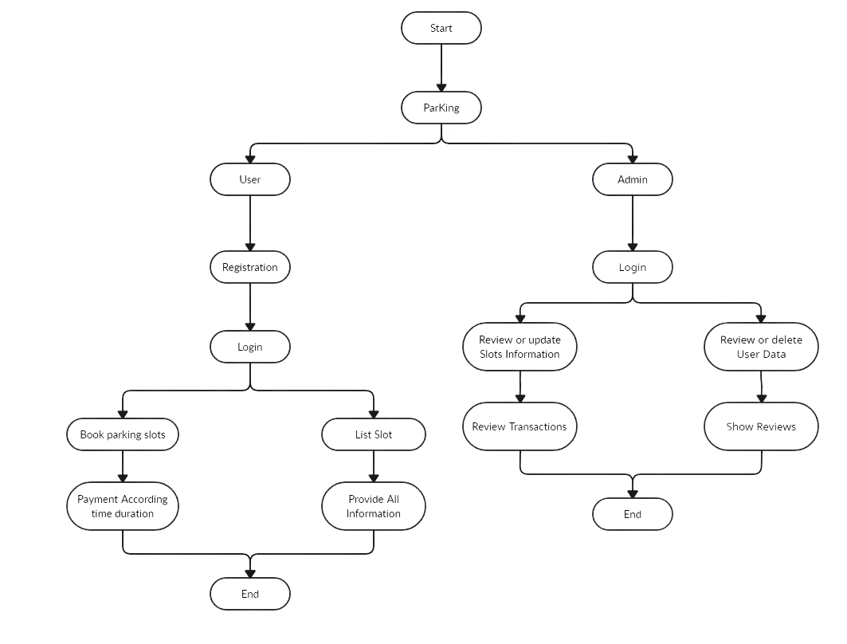

Fig 3.1 Business Process Modelling

**3.2 Requirement Collection and Analysis**

Collecting requirements is crucial for achieving a more systematic task completion. Analyzing these requirements is essential to effectively fulfill the assignment. Through the thorough gathering and analysis of each criterion, the assignment can be expedited.

**3.2.1** **Functional Requirement**

The functional requirements of our smart parking management system encompass a comprehensive set of features aimed at creating an efficient, user-friendly, and technologically advanced platform.

* **User Registration and Authentication**: Enable users to create accounts securely and authenticate their identities for accessing the system.
* **Parking Space Listings**: Allow space providers to easily list and manage their parking spaces, providing details such as location, pricing, and availability.
* **Real-time Availability Tracking**: Implement a dynamic system that continuously monitors and updates the real-time availability of parking spaces for users.
* **Booking and Reservation**: Facilitate a straightforward booking process, enabling users to reserve parking spaces based on their preferences and needs.
* **Payment Integration**: Integrate a secure and efficient payment system that allows users to make transactions seamlessly within the app.
* **User Account Management**: Enable users to manage their accounts, review booking history, and update personal information through a user-friendly interface.
* **Admin Dashboard**: Implement an administrative dashboard for system administrators to monitor and manage user activity, resolve issues, and access analytics.

**3.2.2 Non-functional Requirement**

The non-functional requirements for our smart parking management system encompass critical aspects that contribute to the system's performance, usability, security, and adaptability. These requirements are fundamental to ensuring a robust and efficient platform.

* **User Feedback and Ratings**: Include a feedback and rating system to gather user input, fostering continuous improvement and enhancing the overall user experience.
* **Booking Viewing:** Customers should be able to see their reservations and associated data.
* **Performance**: The system should demonstrate high performance, with rapid response times for user interactions and real-time updates on parking space availability.
* **Scalability:** The architecture should be scalable to accommodate a growing user base and an increasing number of parking space providers.
* **Reliability:** The system must exhibit high reliability, minimizing downtime and ensuring consistent functionality.
* **Security:** Robust security measures should be in place to protect user data, financial transactions, and the overall integrity of the system.

## 3.3. Use Case Modelling and Description

Applying use case modeling proves to be a valuable tool in developing the "ParKing - A Web Based Smart Parking System." It aids in identifying the system's capabilities and interactions, providing a clear understanding of how users will interact with the system's structure. In this context, we delineate several important use cases relevant to the project.

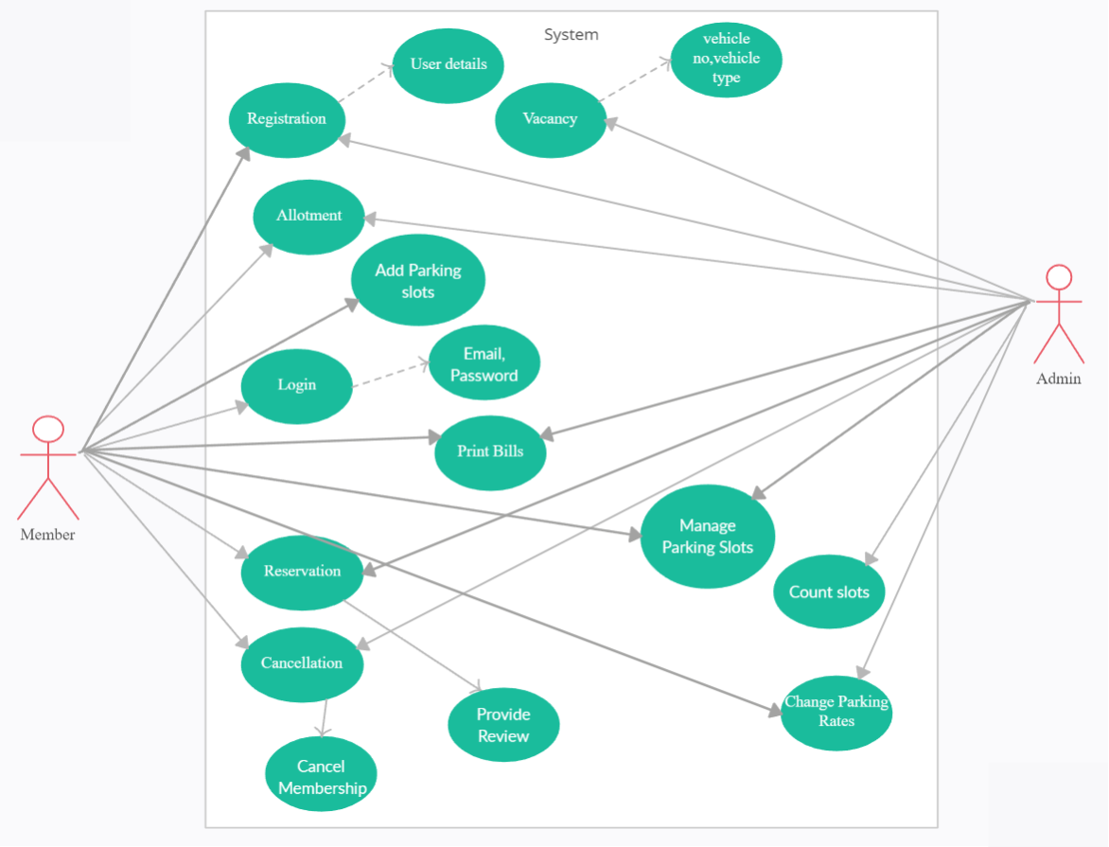

Fig 3.3 Use case model

**Actor**: User, Admin

**Primary Actor**: User.

**1. Search for Parking Space:**

Description: The driver accesses the application, inputs search criteria (location, pricing, etc.), and views a list of available parking spaces on the map. The driver can further filter and explore details for each space.

**2. Book Parking Space:**

Description: Upon selecting a preferred parking space, the driver initiates the booking process. The driver specifies the duration, confirms the booking, and completes the payment transaction.

**3. List Parking Space:**

Description: Parking Space Providers log into the platform, list available parking spaces, and input details such as location, pricing, and availability schedules.

**4. Monitor Bookings:**

Description: Parking Space Providers monitor incoming booking requests, confirm reservations, and ensure the accurate availability status of their spaces.

**5. Cancel Booking:**

Description: Drivers have the option to cancel a booked parking space within a specified time frame, triggering a refund process if applicable.

**6. Provide Feedback and Rating:**

Description: After utilizing a parking space, the driver can provide feedback and ratings, contributing to the overall reputation of the space and assisting other users in their decisions.

**7. View Booking History:**

Description: Drivers can access their booking history, reviewing details of past parking space reservations for reference or record-keeping.

This use case model and descriptions outline the key interactions and functionalities of our smart parking management system, facilitating a user-centric and efficient experience for both drivers and parking space providers.

**8. Contact Functionality**

Description: Users as well as administrators may utilize the contact capability to engage with the support staff or any additional pertinent employees. Users may enquire about items or report concerns, while executives can reply to user requests or complaint.

**9. Payment Verification**

Description: Supervisors have the obligation to validate transactions made by clients. This use case requires evaluating payment data, verifying completed payments, and changing the current condition of reservations or orders appropriately.

* 1. **Design Requirements**

Design standards play a vital role in aesthetics as they enhance our ability to present it to others in a more appealing manner. We aimed for efficiency by making it straightforward and lightweight for all users. It is user-friendly, functioning as a web-based program.

## System Requirements

**Languages:**

* HTML
* CSS
* Laravel
* Bootstrap
* PHP
* Ajax
* JS

**Tools:**

* Visual code
* Composer
* Browser

## E-R Diagram

The ERD diagram seems to depict a database containing items identified by that name. In other words, entity-relationship graphs commonly illustrate the database logic. ER-dependent diagrams typically include three main concepts: entities, attributes, and relationships. People are depicted in various ways in ER charts, often represented by ovals and diamond forms that use rectangles to indicate connections. The subsequent presentation showcases the primary tables along with the relationships among them.

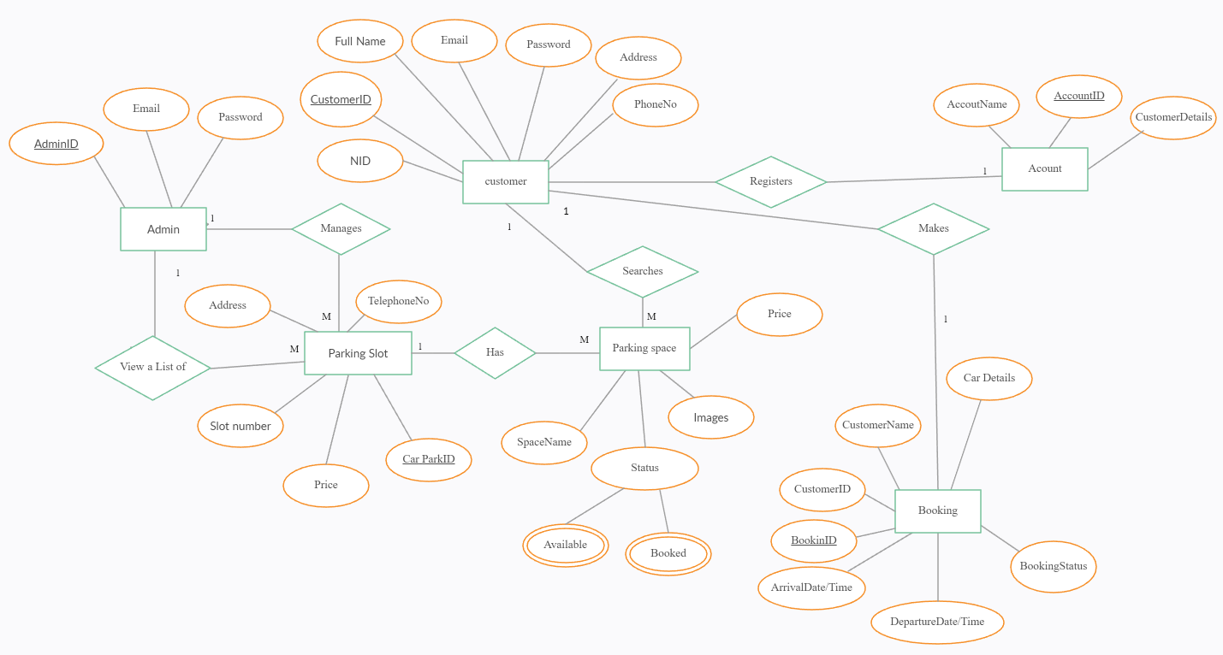

Figure 3.6: E-R Diagram

## CHAPTER 4

## DESIGN SPECIFICATION

## 4.1 Front-end Design

Creating a simple and user-friendly front-end design is crucial for ensuring an excellent user experience in the Smart Parking System. Here is a concise overview of the design's front-end aspects.

## 4.1.1 Home page

This is the Homepage interface. On this page details about our services and who we are shown also some user review and a contact form are shown

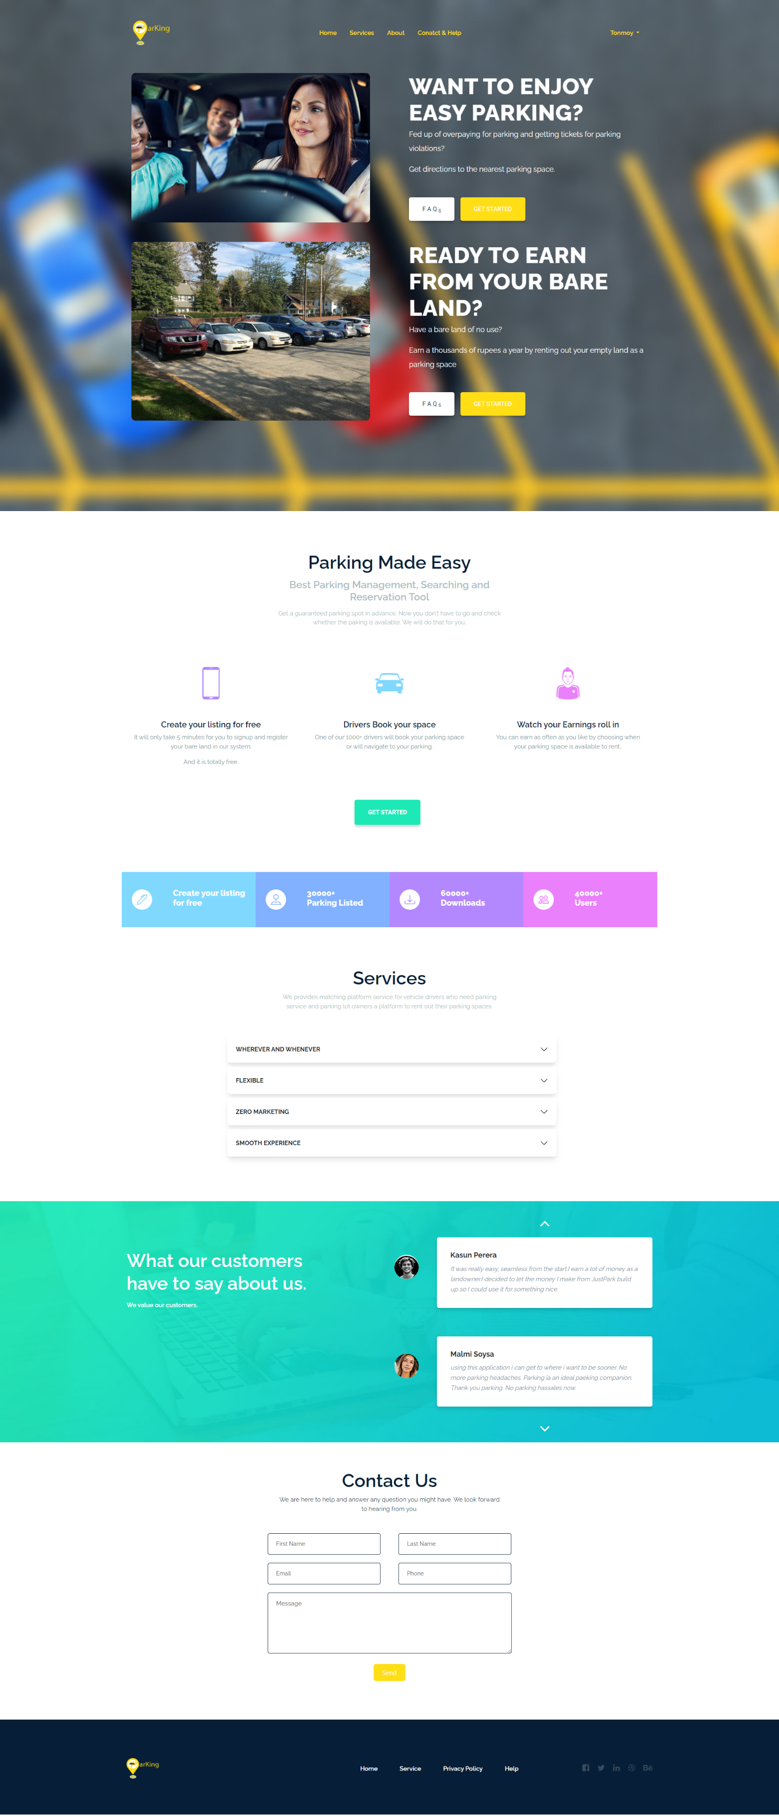

Fig.4.1.1 Home Page

## 4.1.2 Login Page

This serves as the login screen where clients and admin can access our system by entering their passwords and email. Failure to meet these requirements will prevent individuals from making any purchases on the website.

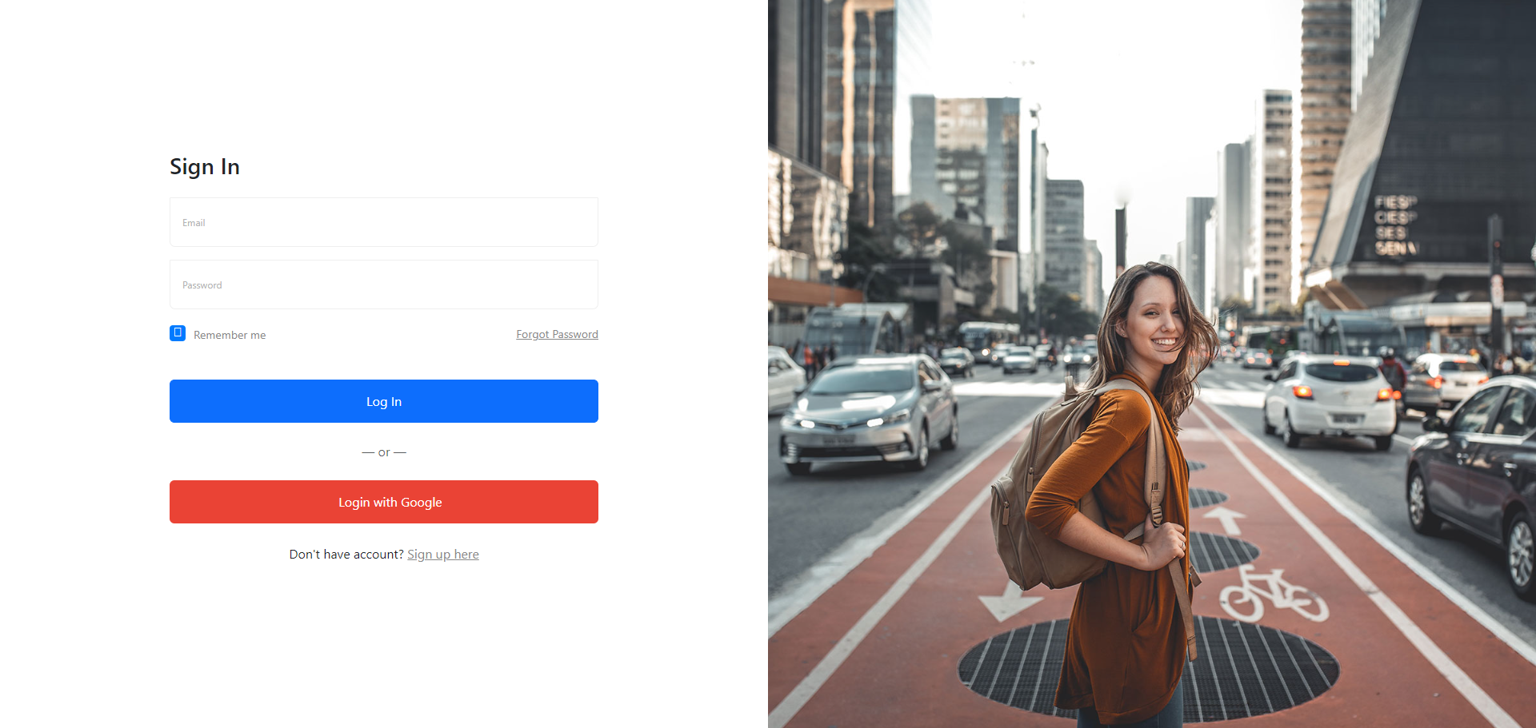

Fig.4.1.2 Login Page

## 4.1.3 Register Page

The registration page allows individuals to create accounts with our system by providing essential information, including passwords and email. Without completing this registration process, users will be unable to login.

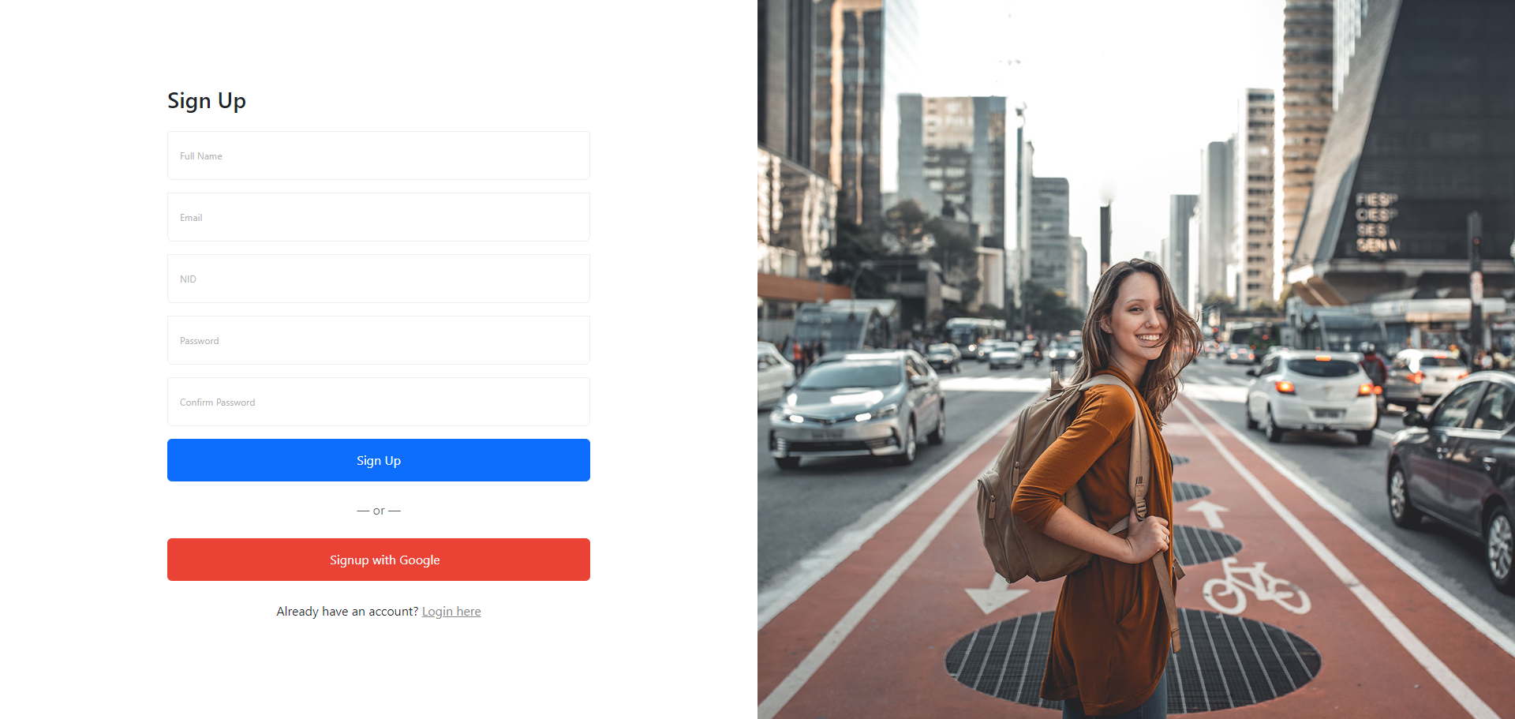

Fig.4.1.3 Registration Page

## 4.1.4 Service Page

The service page allows individuals to choose from either to search location it can be either based on provided location or users current location or list their empty area or garage to earn some money.

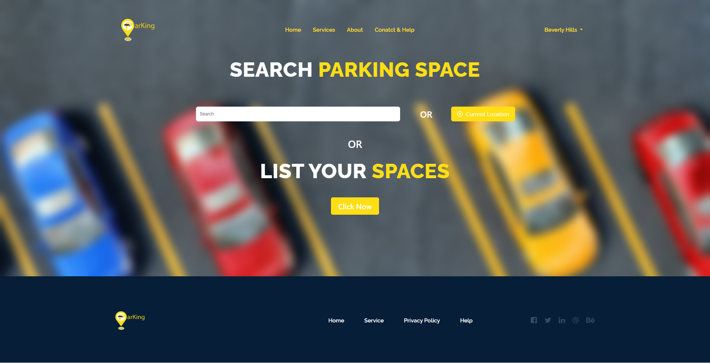

Fig.4.1.2 Login & Registration Page

## 4.1.5 Space Listing Page

The allows user to list their empty spaces or garage by providing some information.

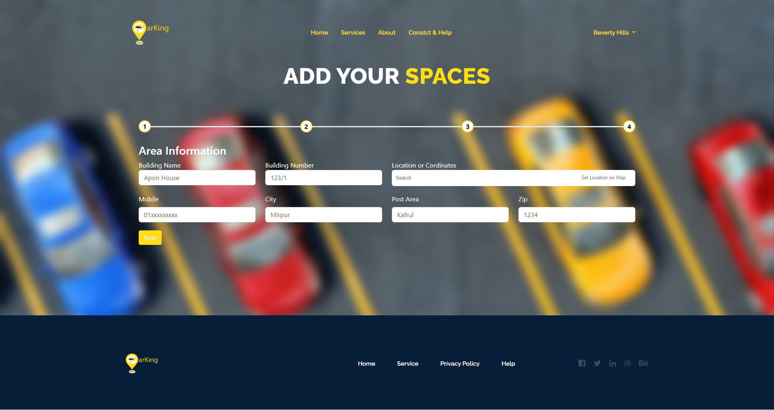

Fig.4.1.2 Login & Registration Page

## 4.1.6 Parking Location Page

The service page allows individuals to choose from either to search location it can be either based on provided location or users current location or list their empty area or garage to earn some money.

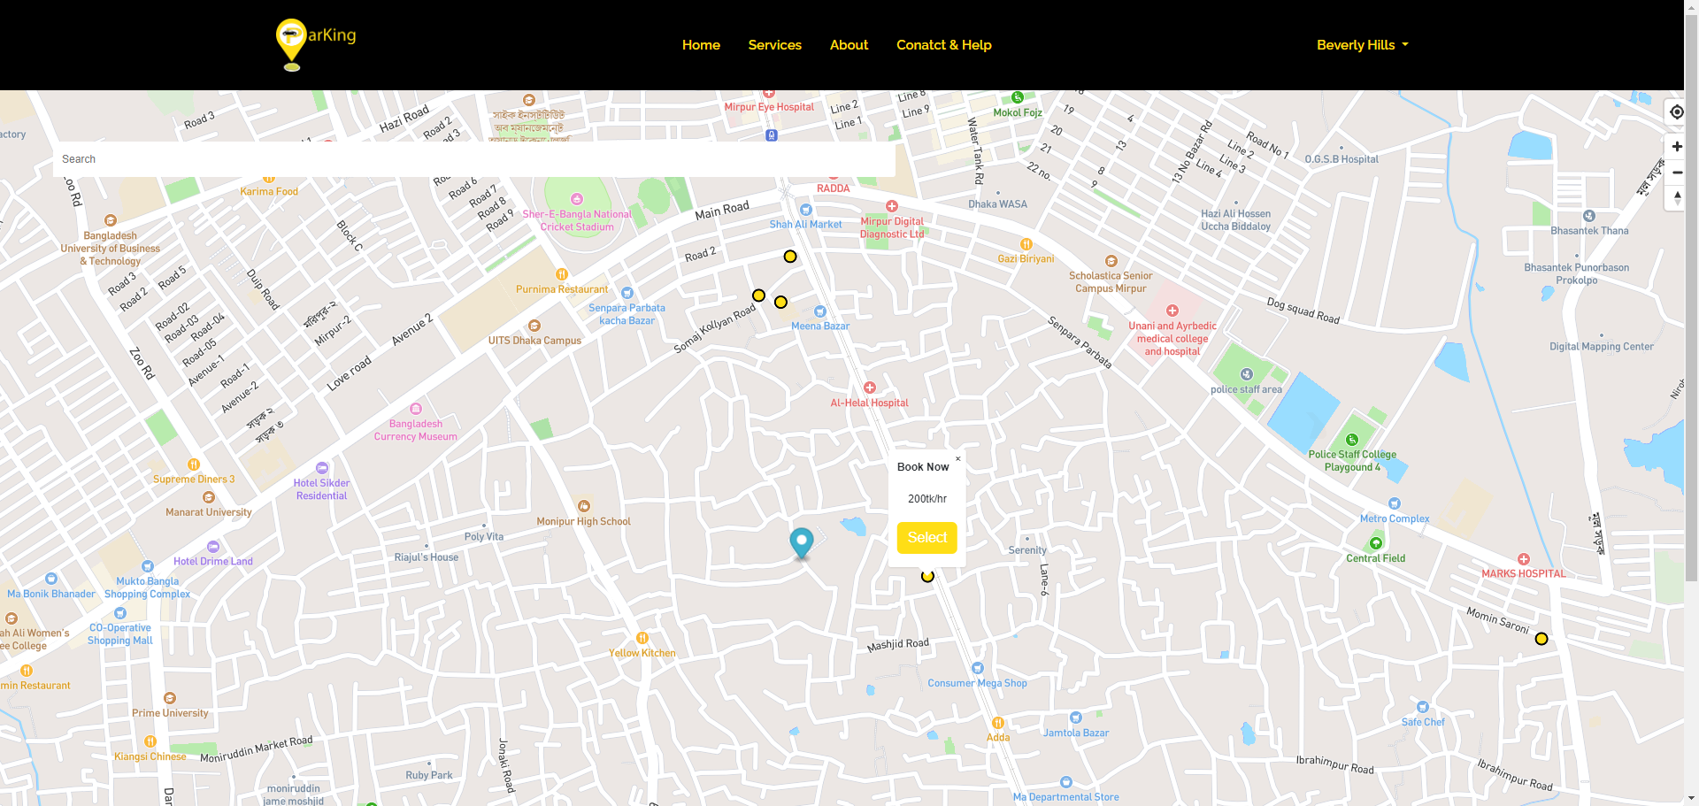

Fig.4.1.6 Parking Location Page

After selecting a location, a popup will be shown where all detailed information will be shown. By providing booking start date and time and end date and time user will be redirected to the payment page.

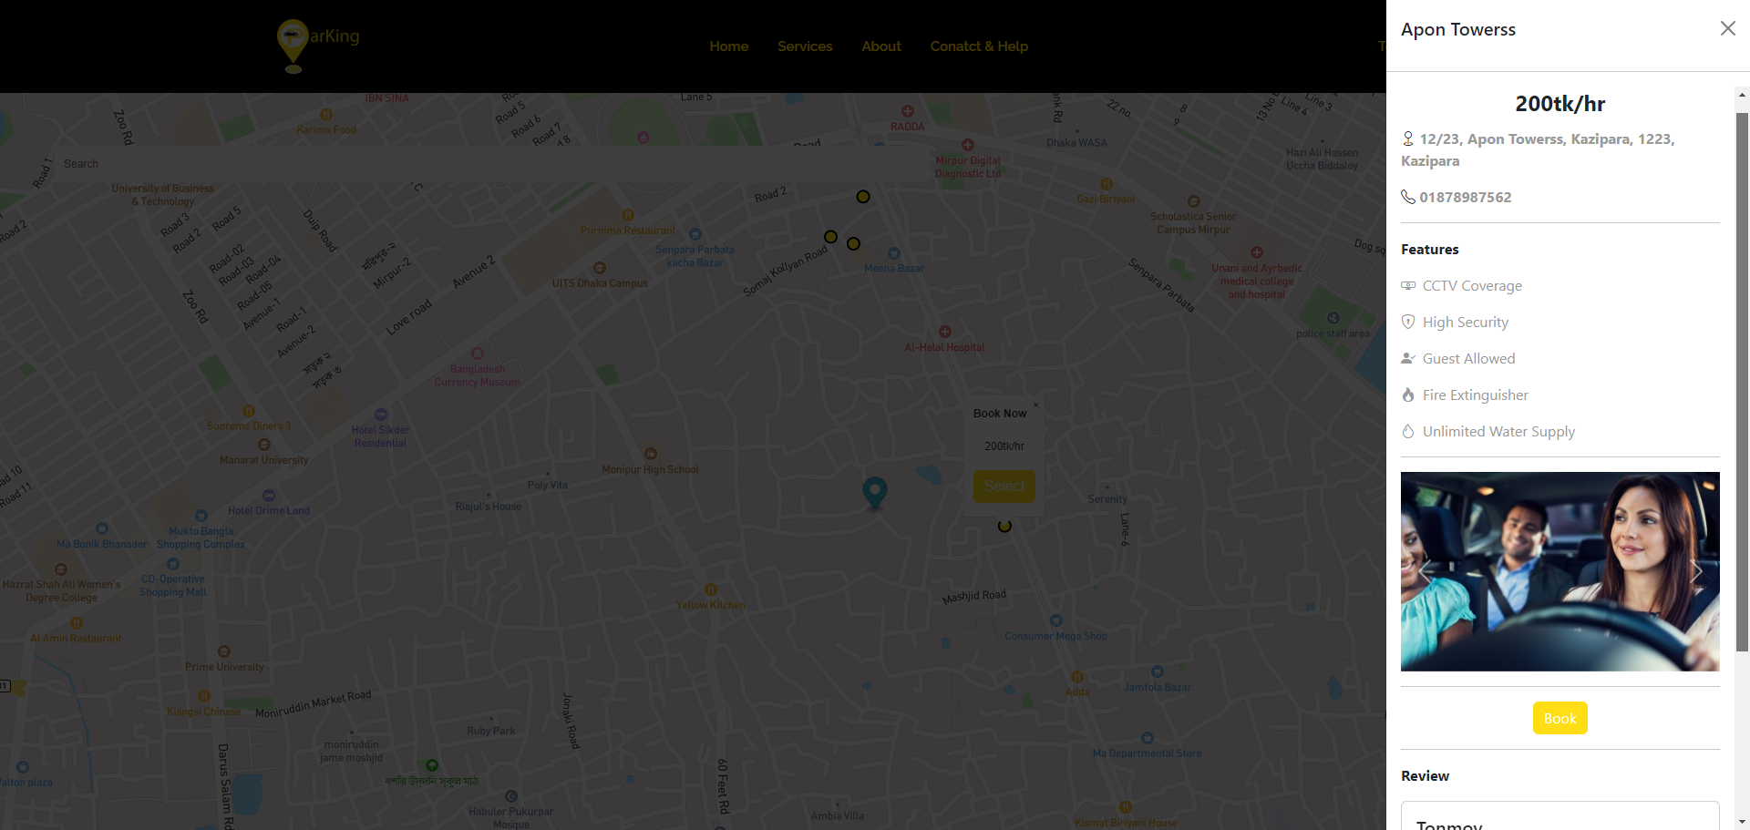

Fig.4.1.6.1 Parking Location Page (with offcanvas)

## 4.1.7 Payment Page

In this page user will see total amount, slot number and short information on parking area owner. User will provide valid information. User can pay either by card or by cash.

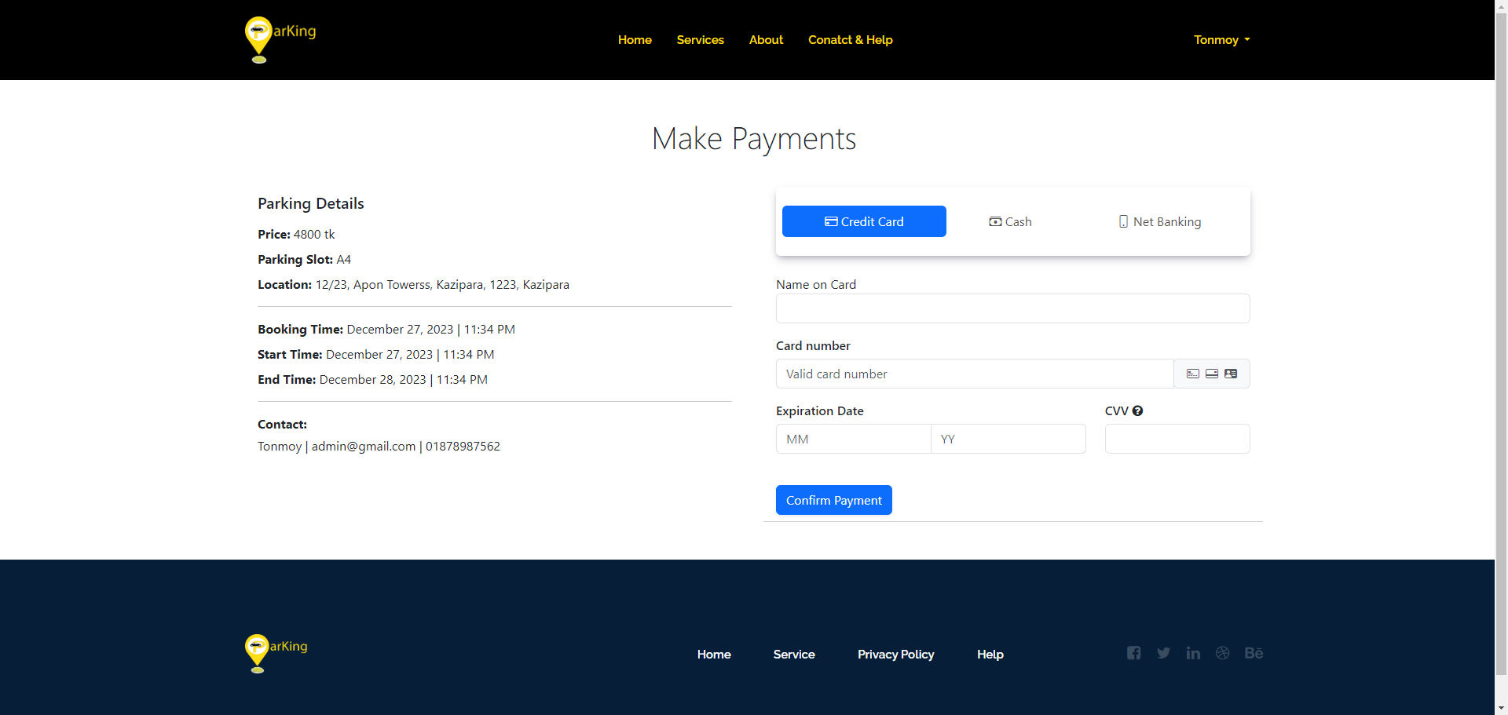

Fig.4.1.7 Payment Page

## 4.1.8 Direction Page

In this page user will see total amount, slot number and short information on parking area owner. User will provide valid information. User can pay either by card or by cash.

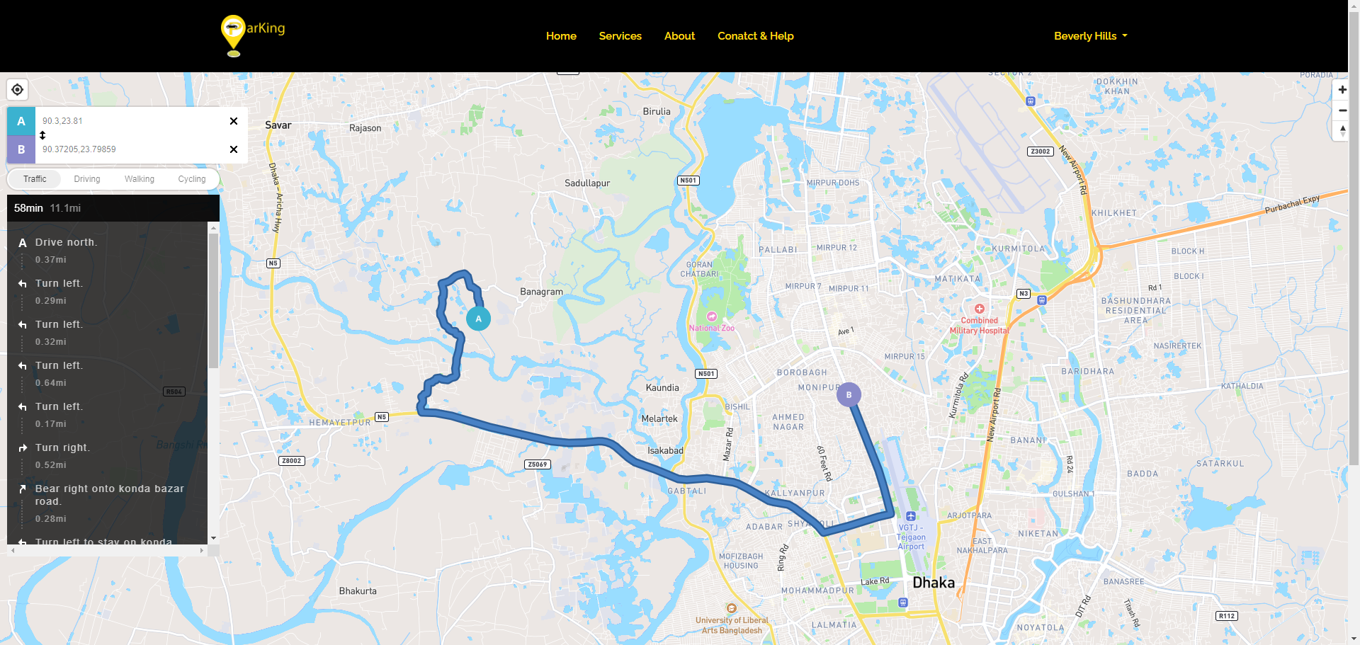

Fig.4.1.8 Direction Page

## 4.1.9 User Dashboard Page

Present essential information and data on the dashboard, including inventory status, recent reservations, and all bookings. Additionally, ensure user details are regularly updated. Utilize graphical representations to illustrate data patterns, facilitating a clearer understanding of vital information for users.

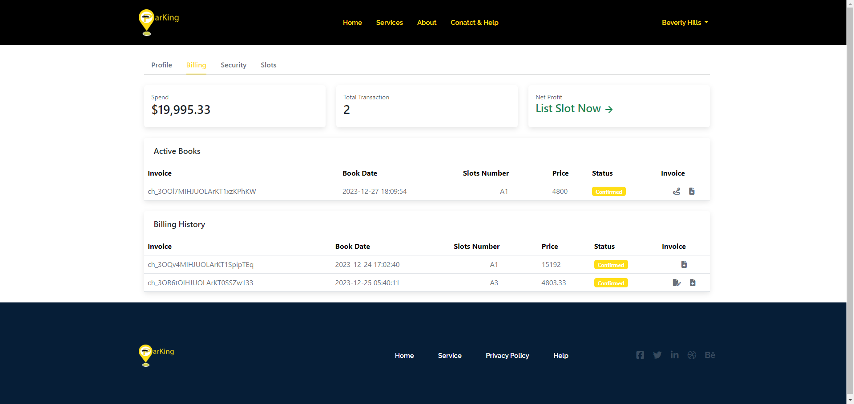

Fig.4.1.9 User Dashboard Page

## 4.1.10 Admin Dashboard Page

This is the administration dashboard design for Administration. Utilize graphical representations to illustrate data patterns, facilitating a clearer understanding of vital information for key information.

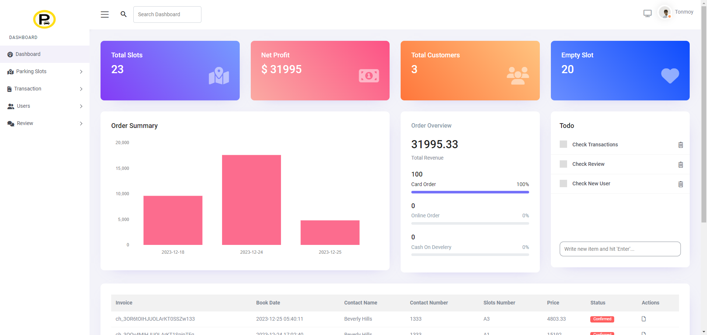

Fig.4.1.10 Admin Dashboard Page

## 4.1.11 Manage Slots

Admin may delete, update parking slots from this section of the site.

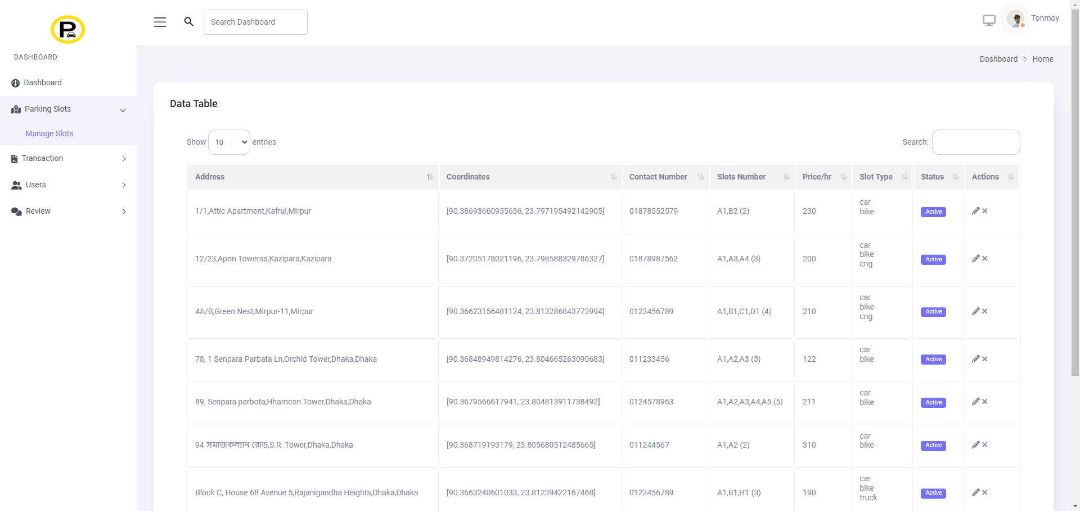

Fig.4.1.11 Manage Slots

## 4.1.12 Manage Transactions

Admin may control transaction from this section of the site. Also can download invoice.

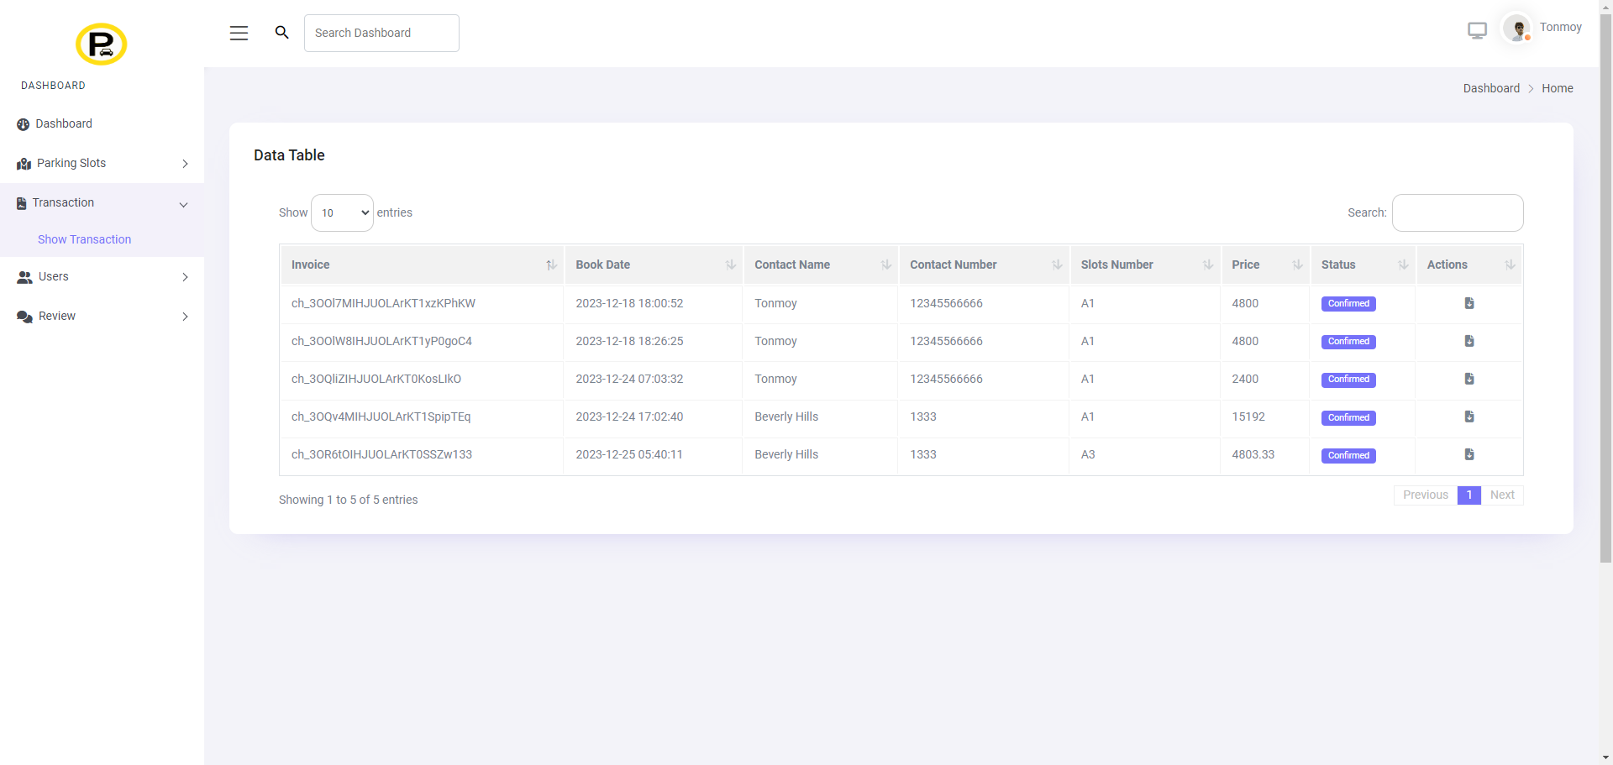

Fig.4.1.12 Manage Transaction

## 4.1.13 Manage Transactions

Admin may control transaction from this section of the site. Also, can download invoice.



Fig.4.1.13 Manage Transaction

## 4.1.14 Manage Users

Admin may control users from this section of the site.

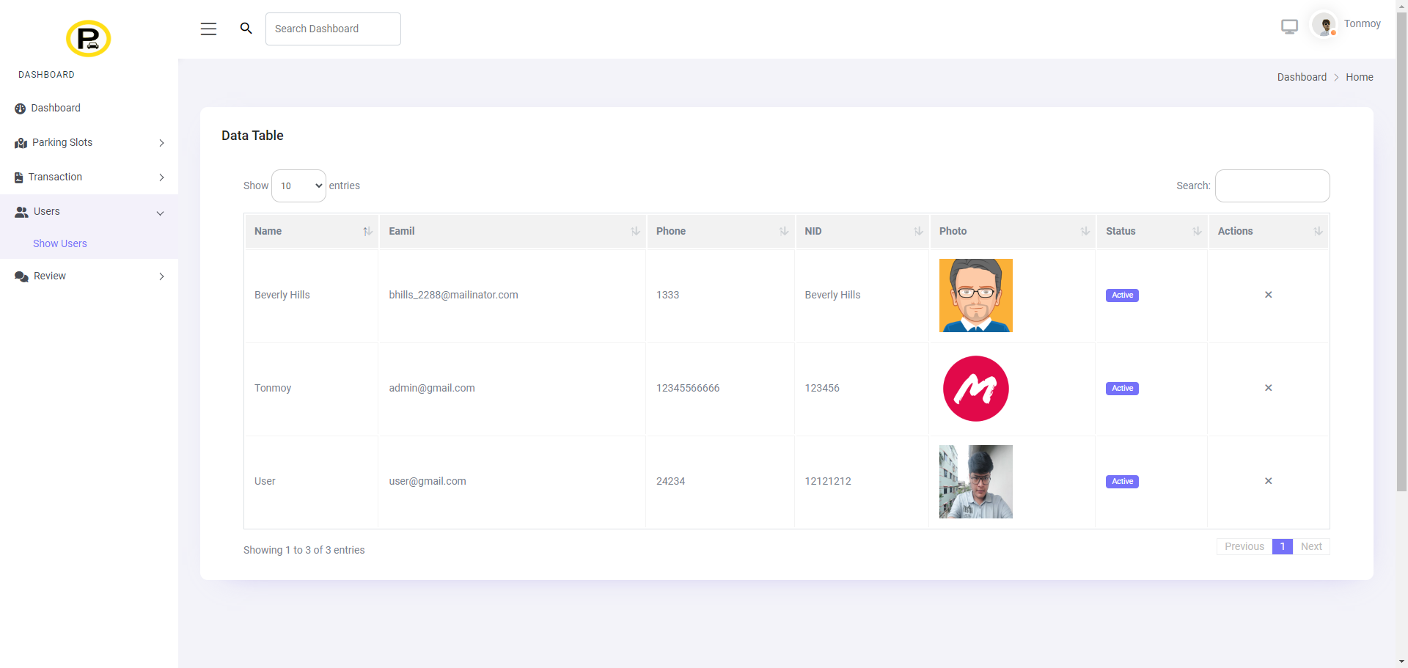

Fig.4.1.14 Manage Users

## 4.1.15 Manage Review

Admin may control users from this section of the site.

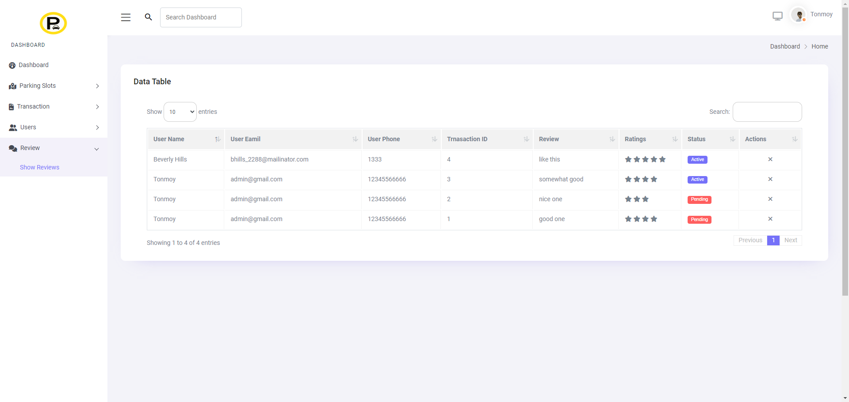

Fig.4.1.14 Manage Review

## 4.2 Back-end Design

The back-end design of our smart parking management system, implemented using the Laravel PHP framework, is focused on ensuring robust functionality, security, and efficient data management. It encompasses the core logic for handling user interactions, managing parking spaces, processing bookings, and maintaining overall system integrity.

## 4.2.1 Visual Studio Code

In the coding aspect, we employ various languages, including HTML, CSS, JavaScript, Ajax and Laravel. Our primary development environment is Visual Studio Code.

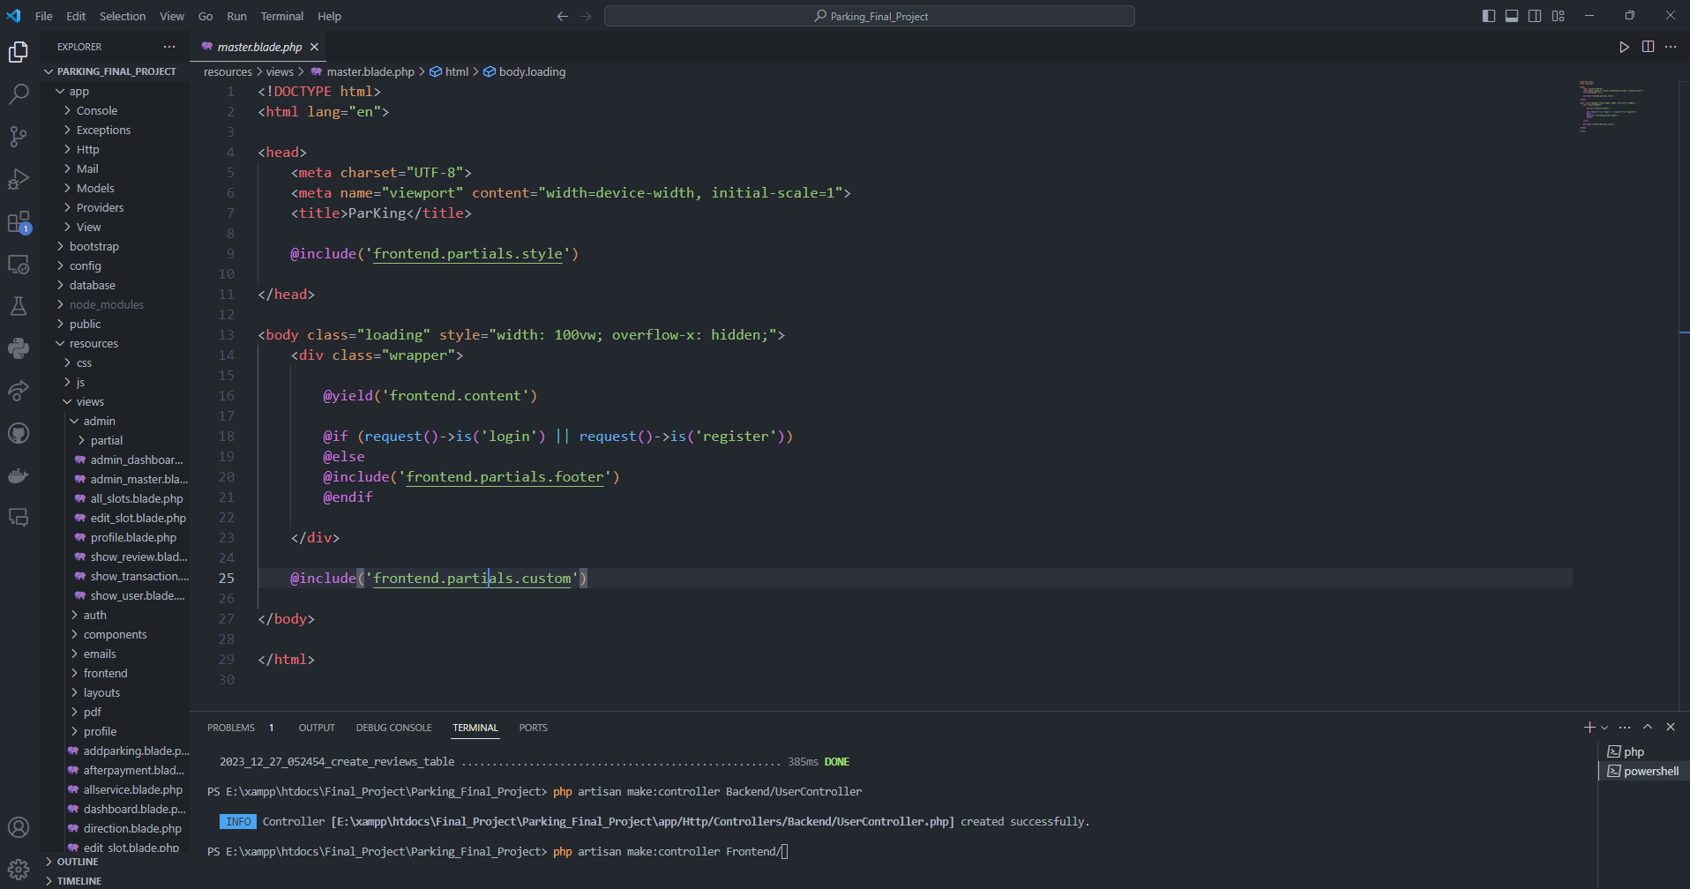

Fig.4.2.1 Visual Studio Code

## 4.2.2 Live Server

We run our application through the XAMPP control panel.

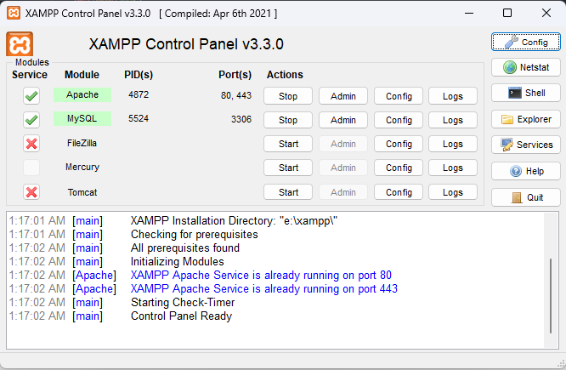

Fig.4.2.2 Live Server

## 4.2.3 Manage Database

We utilize PhpMyAdmin and MySQL to manage the database files of our application.

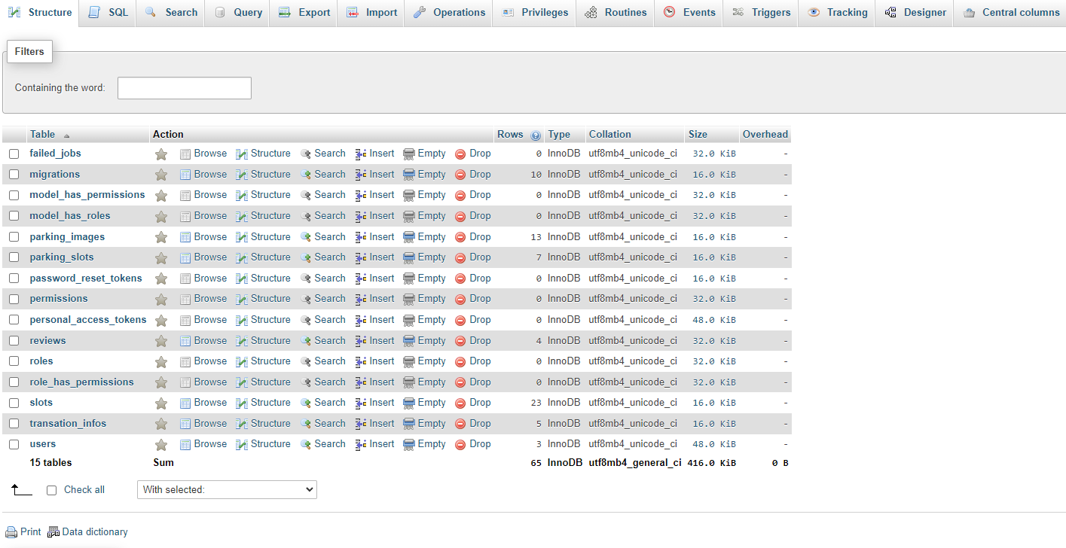

Fig.4.2.3 Manage Database

# CHAPTER 5 IMPLEMENTATION AND TESTING

It is necessary to make it clear that this project was designed and developed entirely based on collecting information from existing systems, concepts and imaginary scenarios. To remind the readers of this report, there are many developers who are still arguing about the core concept of different components of the android based education system. Their opinion is that we are trying to implement the new system

## Implementation of Front-End Design

The screenshots below show the main project view. Capture an image of what you see on your mobile screen and how use it.

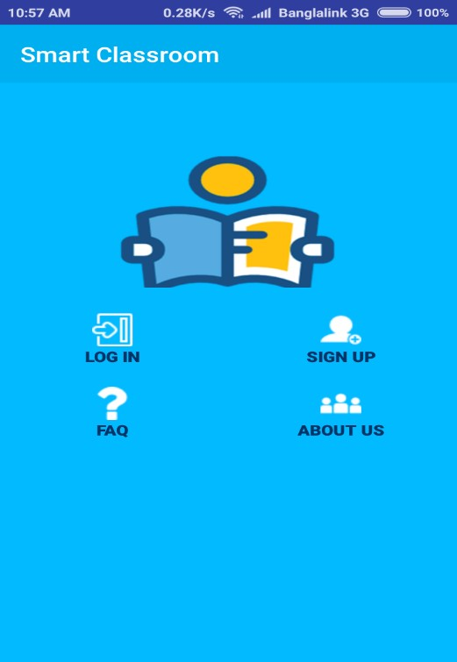**Home Activity:** In the smart classroom home activity there are four option available

Figure 5.1: Smart Classroom Home Activity

**Sign Up:** Users need to fill up sign up form to create an account and access smart classroom.

**Sign Up Form Fields Validation:** Users need to fill up sign up form with valid information.

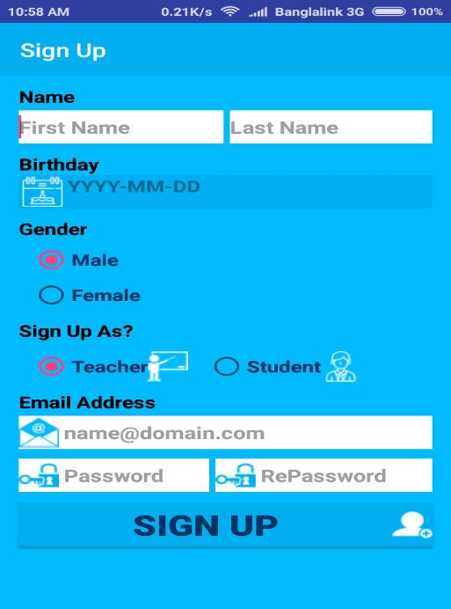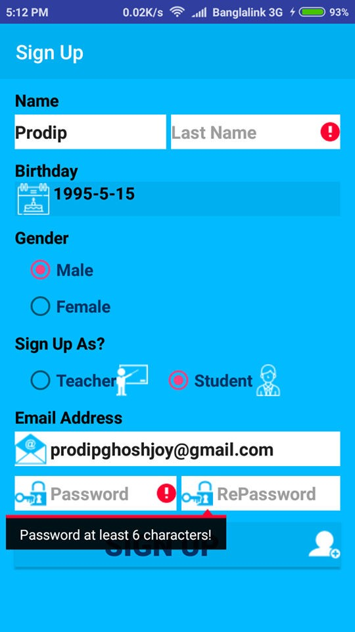

Figure 5.2: Sign Up and Sign Up Form Fields Validation

**Log In and Log In Fields Validation**: Use need to enter valid email address and password.

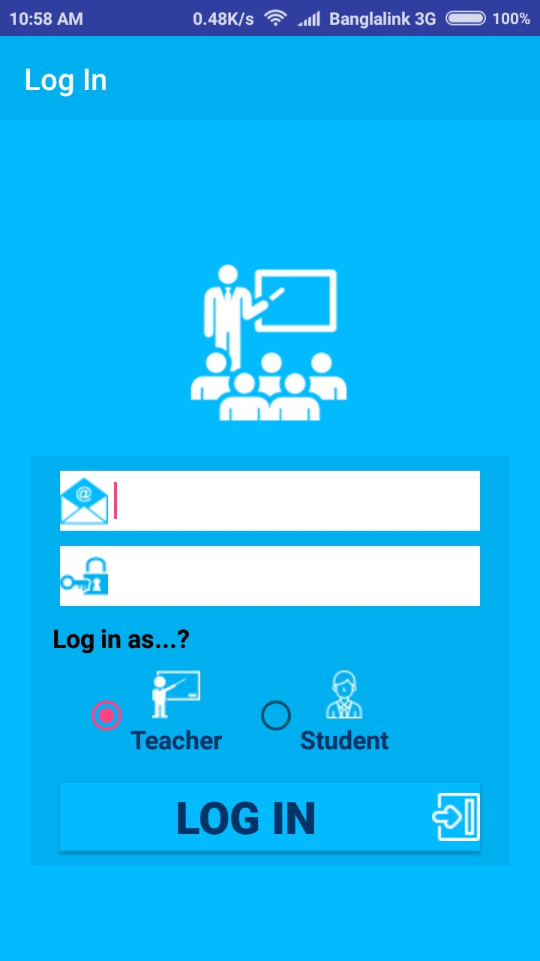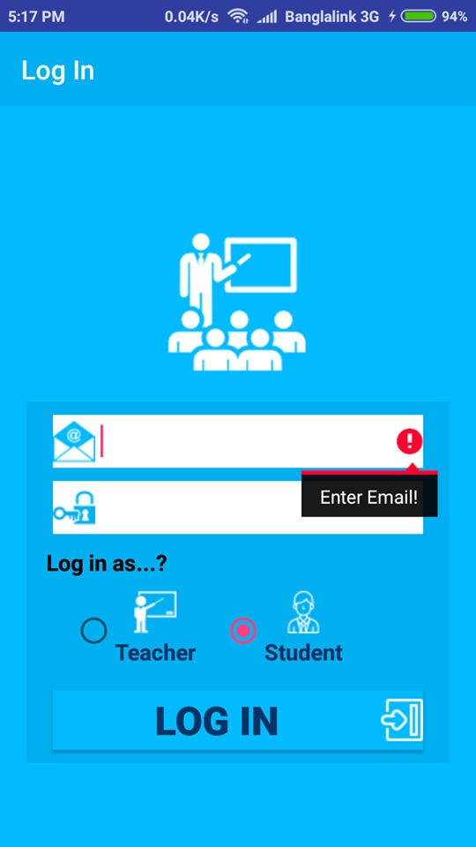

Figure 5.3: Log In and Log In Fields Validation

**After Log In:** After successfully login teachers and students can access all features of smart classroom.

**Noticeboard:** Where students get all kinds of notice.

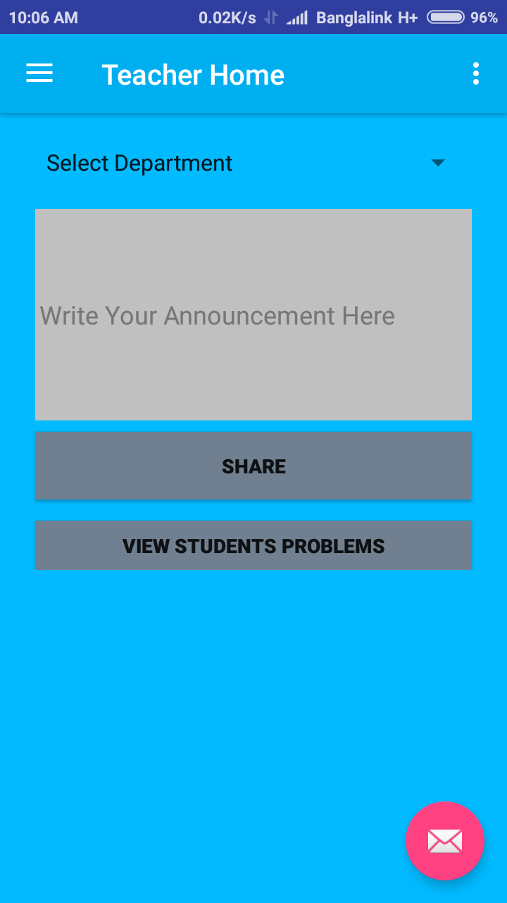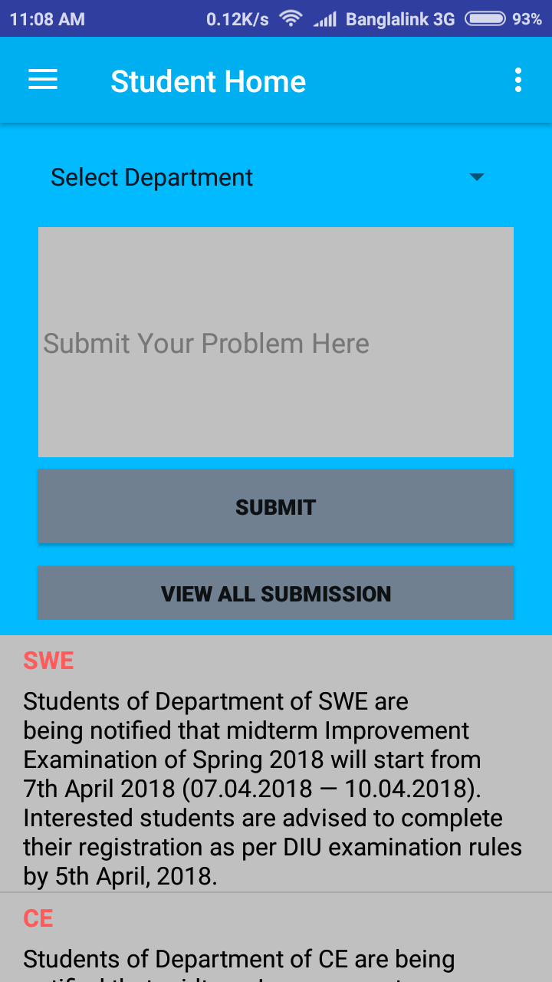

Figure 5.4: Home Activity and Noticeboard

**Features: S**pecific options for teachers and students

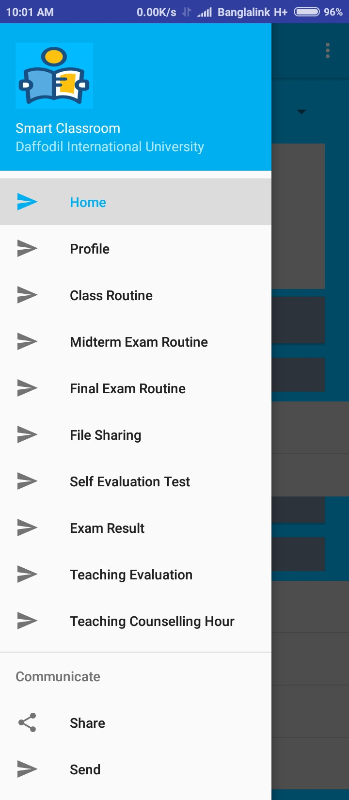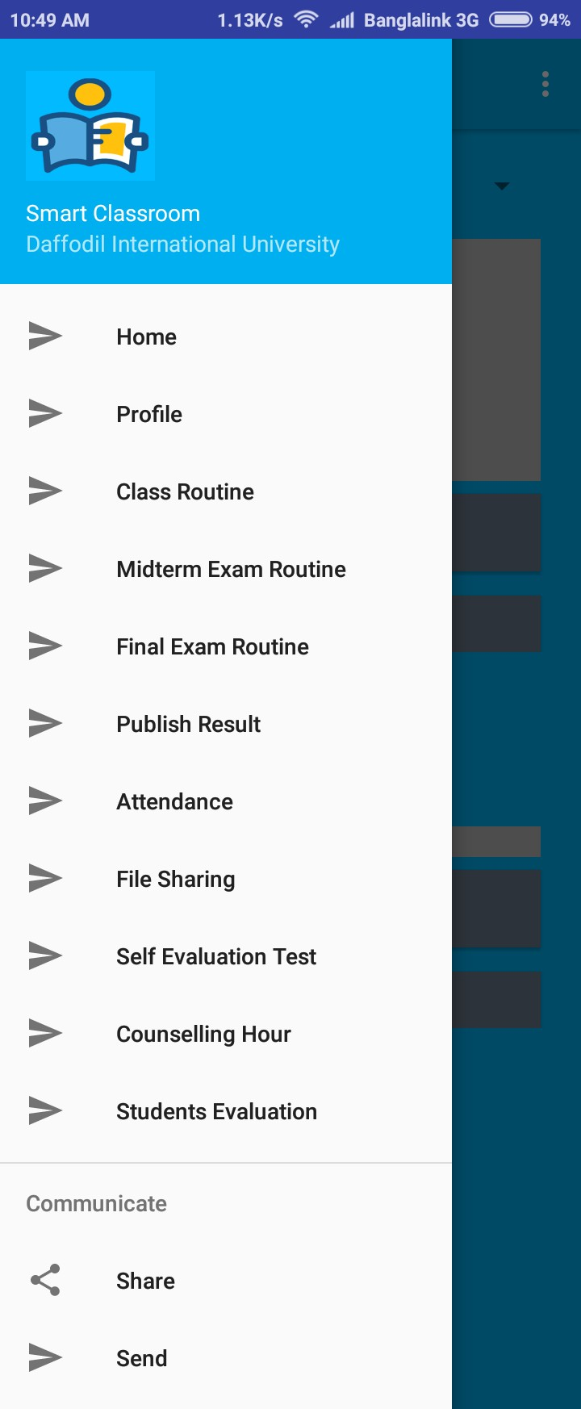

Figure 5.5: Specific Options for Teachers and Students

**Attendance:** Students attendance system.

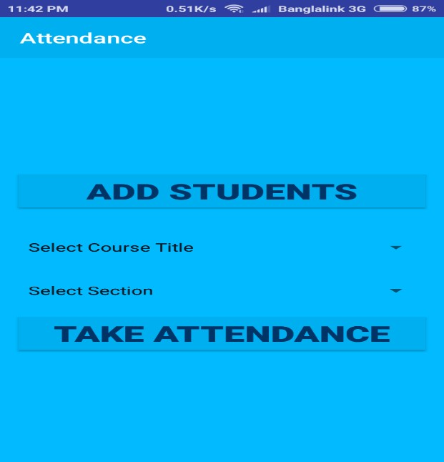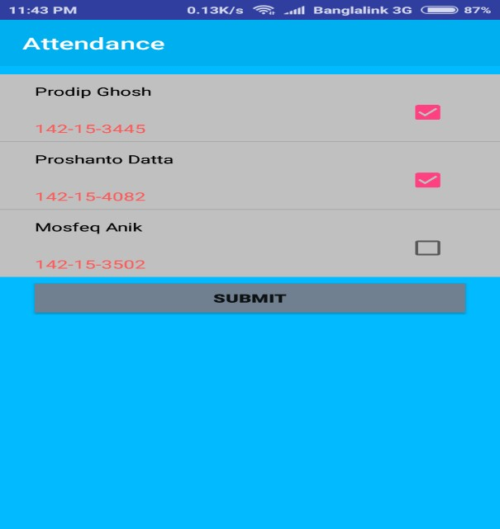

Figure 5.6: Attendance

**Evaluation Test:** Need to answer some question

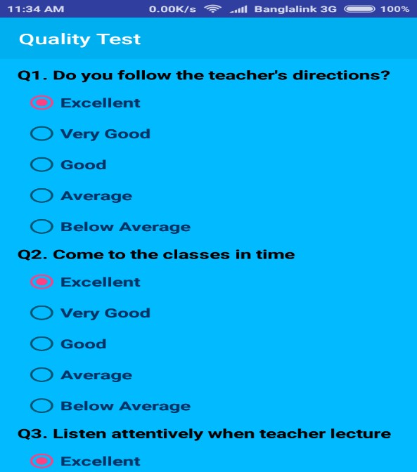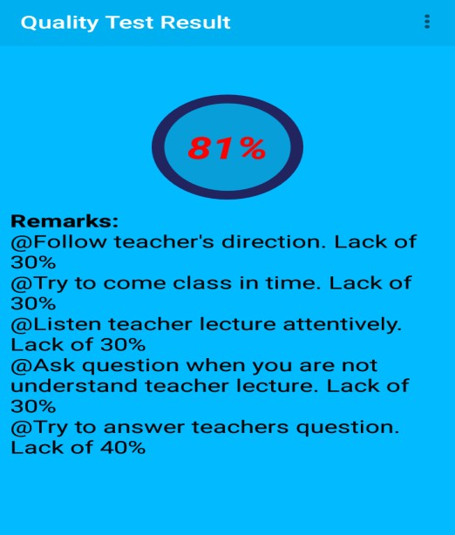**Remarks:** Offer some suggestion for focusing on desired outcomes.

Figure 5.7: Evaluation Test and Remarks

**Result Publish:** Quiz, Midterm examination, final examination result publish.

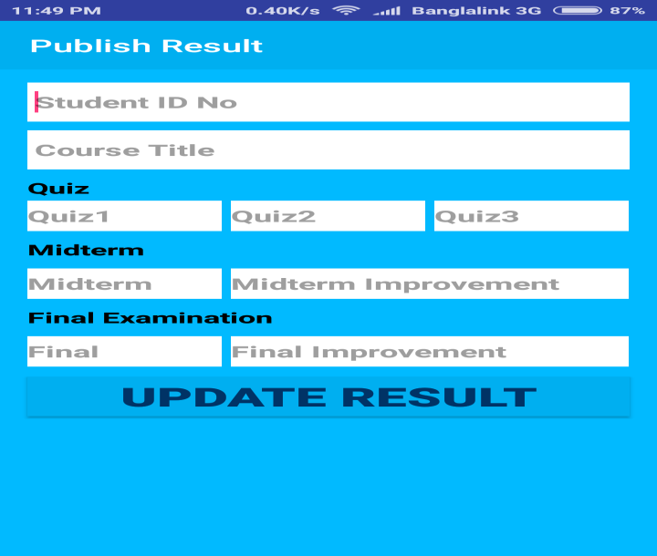

Figure 5.8: Result Publish

**Routine:** Find out class, midterm, final examination routine.

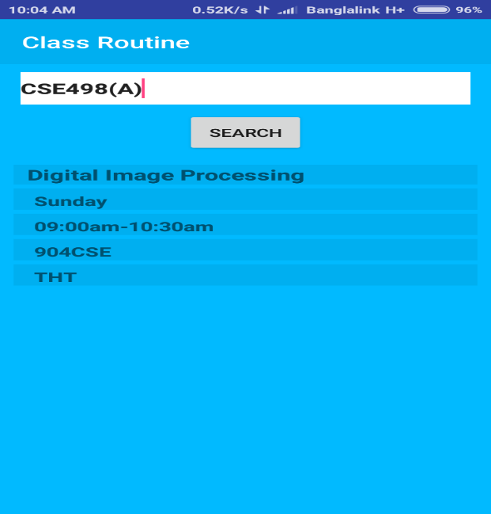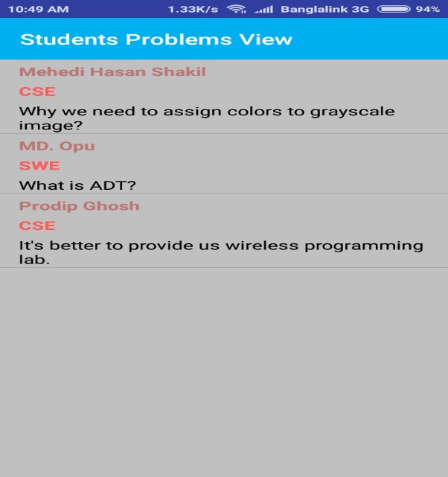**Students Problems View:** Students can share their problems.

Figure 5.9: Routine and Students Problems View

## Implementation of Back-End Design

The following design for the smart classroom database is selected to system application. Database design is the process of producing a detailed data model of a database. This logical data model contains all the needed logical and physical design choices and physical storage parameters needed to generate a design in a data definition language, which can then be used to create a database. A fully attributed data model contains detailed attributes for each entity. The term database design can be used to describe many different parts of the design of an overall database system. Principally, and most correctly, it can be thought of as the logical design of the base data structures used to store the data. In the relational model these are the tables and views. However, the term database design could also be used to apply to the overall process of designing, not just the base data structures, but also the forms and queries used as part of the overall database application within the database management system (DBMS).

## Data Table Name

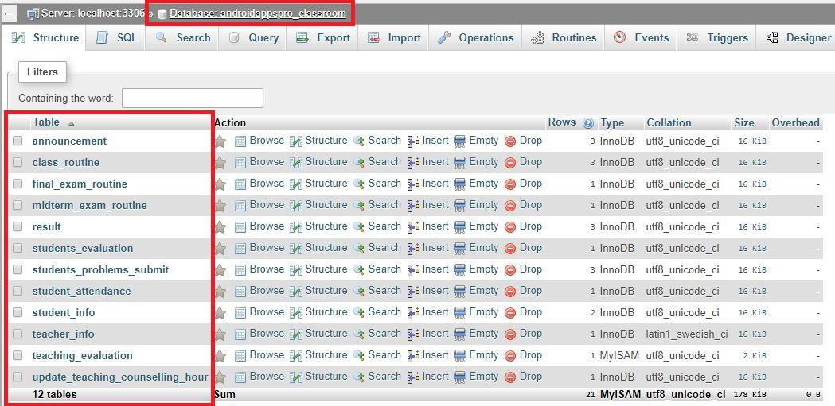The name of the smart classroom's database is androidappspro_classroom that has twelve data tables.

Figure 5.10: Database Table Name

## Data Type Architecture

A data architecture should neutrality set data standards for all its data systems as a vision or a model of the eventual interactions between those data systems. Data integration, for example, should be dependent upon data architecture standards since data integration requires data interactions between two or more data systems.

The following data types for its column and parameter declarations.

* + - * CHARACTER [CHAR [(length)]
      * VARCHAR (length)
      * BOOLEAN
      * SMALLINT
      * INTEGER or INT
      * DECIMAL
      * NUMERIC
      * REAL
      * FLOAT(p)
      * DOUBLE PRECISION
      * DATE
      * TIME
      * TIMESTAMP
      * CLOB [CHARACTER LARGE OBJECT [(length)] or CHAR LARGE OBJECT [(length)]
      * BLOB [BINARY LARGE OBJECT [(length)]

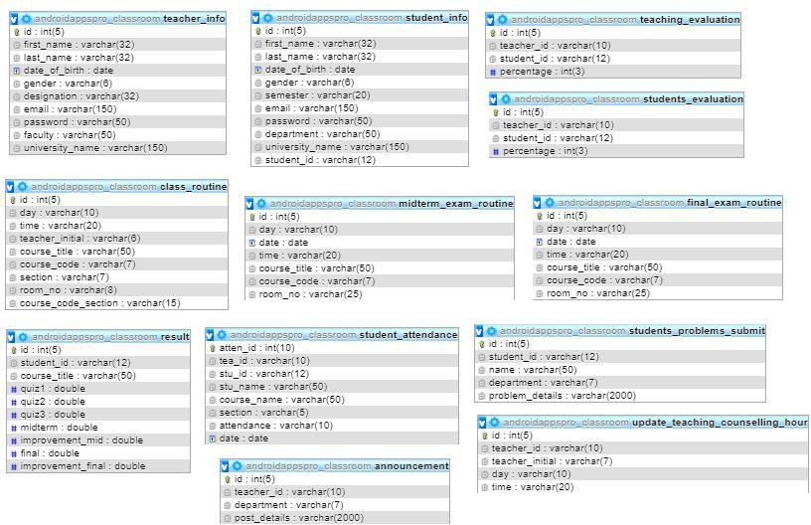

Figure 5.11: Data Type Architecture

## MySQL Database View

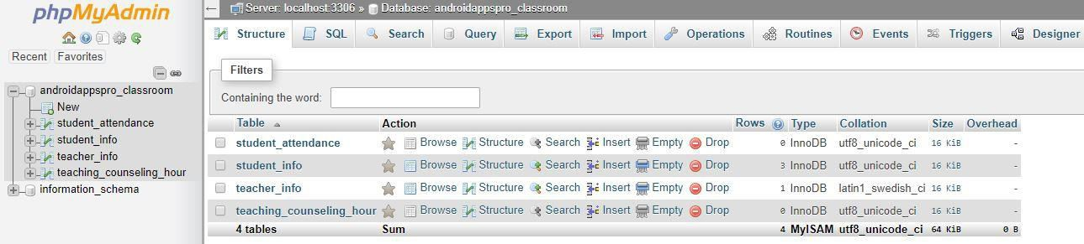

Figure 5.12: MySQL Database View

## Database Table Structure

Here table (**teacher_info)** structure shown below:

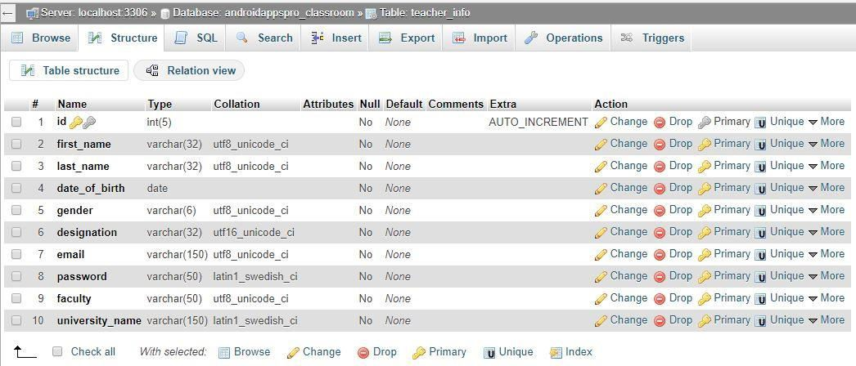

Figure 5.13: Database Table (teacher_info)

## Testing Implementation

This project was judged on the following set of criteria:

**Satisfying requirement specifications:** The project is said to be successful if it satisfies all the requirements such as functional and non-functional requirements. In other words, it should be capable of ensuring the requirement specifications.

**Correctness:** It is one of the critical requirements of software development. Perfectness is the basic demand for service oriented software. Each and every part of the application should work properly and accurately.

**Compatibility and Integrity:** These are two significant conditions to check whether or not the project is successful. The live classroom was created to be compatible with any domain. It was also designed in such a way that it could persuade the virtualization which is considered to be an important factor. Additionally, the evaluation of the system depended on how the application was implemented to the whole system or not.

**Real time management:** The application is about smart classroom. So, it is necessary to maintain the real time scenario. The users of this system should have the ability to maintain this.

**Reliability and security management:** The security is one of the important factors in any service oriented systems. For this reason, the evaluating criteria on the security features that had been taken under account when the system was developed.

**User friendliness:** Friendliness in any applications is also a special criterion to judge the systems. For instance, the users of this solution should feel contented when they are using the system. In essence, a system should have the quality measures properties, such as efficiency, portability, reusability, flexibility, cohesion and loose coupling among different components of the designed software.

## Testing Methodology

Testing In general, software testing is used to find out system errors. A software test can be carried out by examining codes, design and execution of the whole system. Testing is inevitable to improve the quality of the system. Reviewing and testing code is another basic of software engineering that is often overlooked in project development. Testing is an integral part of the system development process. The main Standard for software Testing is contained in the ANSI/IEEE standard 829/1983- Standard for software testing Documentation. Some software testing may also be performed by CAST (Computer Aided Software Testing).

## Functional Testing

In functional testing tester has to validate the application to see that all specified requirements of the user’s whatever we have said in supplemental restraint system have been incorporated or not.

* + - * There are two categories of functional testing:
      * Positive functional testing: testing the application‘s functions with valid input and also verifying that the outputs are correct.
      * Negative functional testing: IT involves exercising application functionality using a combination of invalid inputs some unexpected operating conditions and by some other "out-of-bounds" scenarios.

## Unit Test

Unit testing is generally used in a detailed designing and implementing phase of this project. The rationale of unit test was to find out the defects in this project.

## Compatibility Test

Compatibility Testing, part of software non-functional tests, is testing conducted on the application to evaluate the application‘s with the computing environment. Software compatibility testing can be more appropriately referred to as user experience environment. This project is tested on different types of android mobile to ensure the following-

**Table 5.1: Compatibility Test Result**

|  |  |  |  |
| --- | --- | --- | --- |
| **Android Device Name** | **Screen Size** | **Test** | **Result** |
| Samsung Galaxy Core  Prime | 4.5 inch (480p) | Yes | Okay |
| Samsung Galaxy S II | 4.3 inch (720p) | Yes | Okay |
| Walton Primo GM | 5.0 inch (480p) | Yes | Okay |
| Symphony Xplorer T8  Pro | 8.0 inch  (WXVGA) | Yes | Okay |
| Xiaomi Redmi 4x | 5.0 inch (720p) | Yes | Okay |
| Xiaomi Redmi Note 3  Pro | 5.5 inch (720p) | Yes | Okay |

# CHAPTER 6 CONCLUSION AND FUTURE SCOPE

## Conclusion

Smart Classroom is an android based mobile application that allows users an effective environment of teaching and learning. Both Teachers and Students can be benefitted in training and learning by this application. Classroom environment is user friendly as to navigate easily to find the resources and class lectures. Hope this will be a better solution in the field of learning and teaching for present and future generation.

## Goal

The main goal is to create an android application where both students and teachers can learn and teach at the same time. To build a good community and good relationship between teachers and students is one of the important goals of our application.

## Limitation

* + - The part of the system can be implemented using the current technology although some modifications had to be done at various places
    - Domain hosting bandwidth only 3GB
    - MySQL database storage 1GB
    - For file sharing we use google API.

## Scope for Further Developments

* + - Interface design will be updated
    - More features and functionalities will be added
    - Reliability of the application should be increased
    - File share by using our API.

**REFERENCES**

[1]. J. Kim, K. Lim and Y. Park, “Research on the development of a hybrid instructional model using information technologies: “Flipped Classroom”, International of Conference on Convergence Technology, vol. 2, no. 1, 2013.

[2]. K. H. Bae, “A Study on Development and Application of Cooperative Learning Model for Interdisciplinary Approach in Curriculum Development”, The Journal of Korean society for educational technology, vol. 28, no. 4, 2012, pp. 907-924.

[3]. K. Inae, B. R. Lim and J. Y. Park, “Exploring the theoretical framework and teaching & learning strategies of Smart Learning: Using cases of university classrooms”, The Journal of Korean Association for Educational Methodology, vol. 24, no. 2, 2012, pp. 283-303.

1. Learn about Virtual learning environment, available at << <https://en.wikipedia.org/wiki/Virtual_learning_environment/>>>, last accessed on 06-11-2017 at 12:05pm.
2. Learn about Sublime Text, available at <<<https://en.wikipedia.org/wiki/Sublime_Text/>>>, last accessed on 08-11-2017 at 02:18pm.
3. Available at <<[http://jaago.com.bd/online-school/>>;](http://jaago.com.bd/online-school/%3e%3e%3B) accessed on 14.11.2017, Time: 12:50pm.
4. Jiamao Liu, Junjie Wang and Ning Gu “Several Critical Problems in a Real-time Interactive Virtual Classroom” IEEE International Conference. ©2003 IEEE
5. Google (2012) “Google for Education”; accessed on 05.01.2018, Time: 7.00pm
6. XAMPP, available at <<<https://en.wikipedia.org/wiki/XAMPP/>>>, last accessed on 08-11-2017 at 02:45pm.
7. Android Studio, available at <<<https://en.wikipedia.org/wiki/Android_Studio>>>, last accessed on 02- 10-2017 at 08:43pm.
8. Database, available at <<[http:en.wikipediaorg/wiki/Database](http://en.wikipediaorg/wiki/Database)>>, Accessed Date: 07.02.2018

## Plagiarism Check:

Our project report plagiarism less than 30%

